Problem 1:

% Part A

% Load Iris Data restricted to the first two features

% Plot the data and see how clustered it is

iris = load('data/iris.txt');

X = iris(:,1:2);

X1 = iris(:,1);

X2 = iris(:,2);

Y = iris(:, end);

figure (1)

scatter(X1,X2)

title('Feature 1 and Feature 2 Data Scatter Plot')

xlabel('Feature 1')

ylabel('Feature 2')

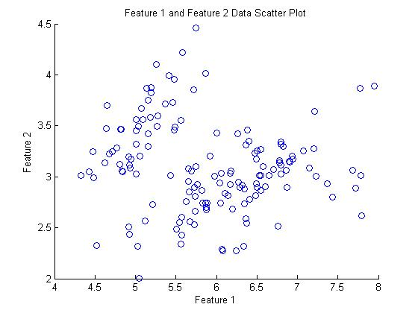

% Part B (k = 5; farthest: choose cluster 1 uniformly, then the point farthest from all clusters so far, etc.; nIter = 1)

iris = load('data/iris.txt');

X = iris(:,1:2);

X1 = iris(:,1);

X2 = iris(:,2);

Y = iris(:, end);

k=5;

[idx,c,sumd] = kmeans(X,k,'farthest',1);

The following images are generated by setting nIter be 1, 100, 10000.

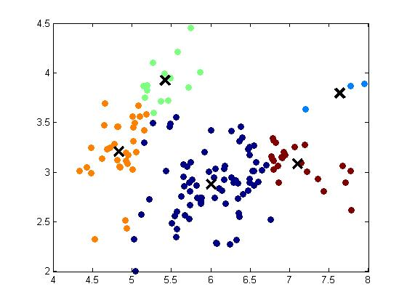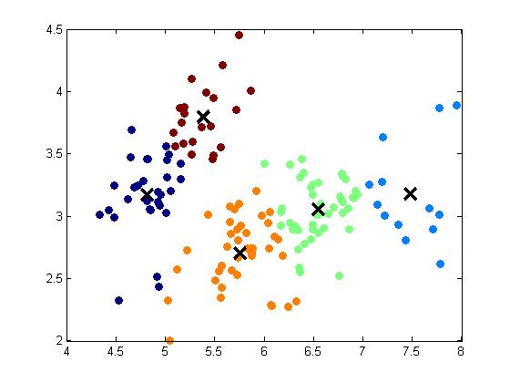

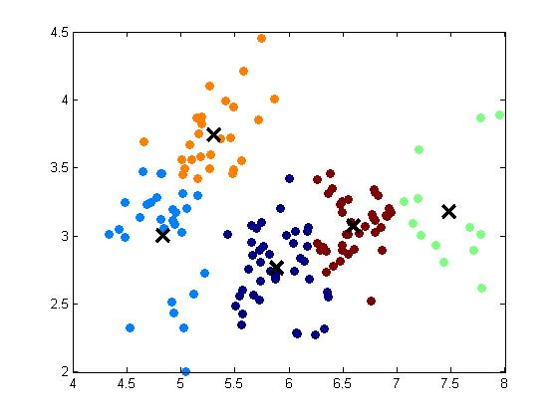

% Part B (k = 20; farthest: choose cluster 1 uniformly, then the point farthest from all clusters so far, etc.; nIter = 1)

iris = load('data/iris.txt');

X = iris(:,1:2);

X1 = iris(:,1);

X2 = iris(:,2);

Y = iris(:, end);

k=20;

[idx,c,sumd] = kmeans(X,k,'farthest',1);

The following images are generated by setting nIter be 1, 100, 10000.

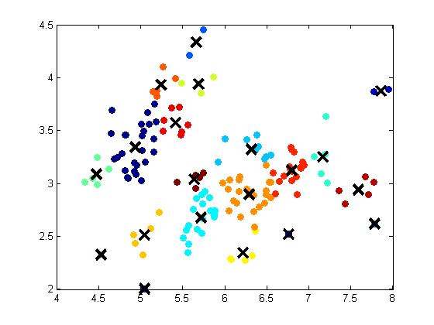

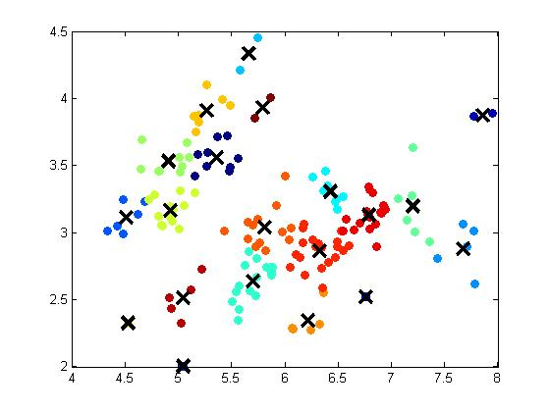

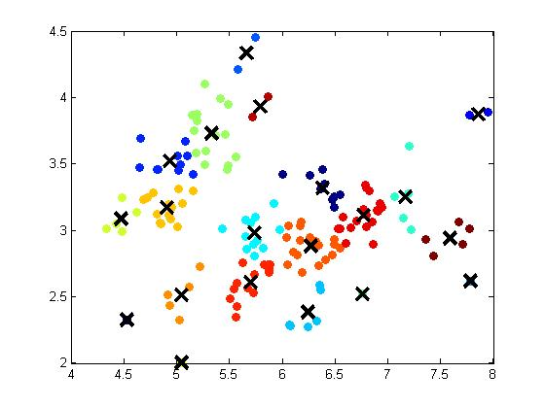

% Problem 1

% Part C (Run agglomerative clustering on the data using single linkage and

% complete linkage)

% k = 5

% * Doens't have to try diff initizations

iris = load('data/iris.txt');

X = iris(:,1:2);

X1 = iris(:,1);

X2 = iris(:,2);

Y = iris(:, end);

k=5;

% [z join] = agglomCluster(X,nClust,method,join)

% [z, join] = hcluster(X,K,method, [,join]) : perform heirarchical agglomerative clustering

% z = assignment of data into K clusters

% method = {'min','max,'means','average'} : cluster distance / linkage type (single,complete,mean,avg)

% join = sequence of joining operations performed by hcluster (pass to avoid re-clustering for new K)

[z] = agglomCluster(X,k,'max'); %'max' refer to complete

fig(1);

plotClassify2D([],X,z);

hold on;

% plot(c(:,1),c(:,2),'kx','markersize',14,'linewidth',3);

hold off;

The following plot referring to ‘max = complete’ and ‘min = single’ with k=5

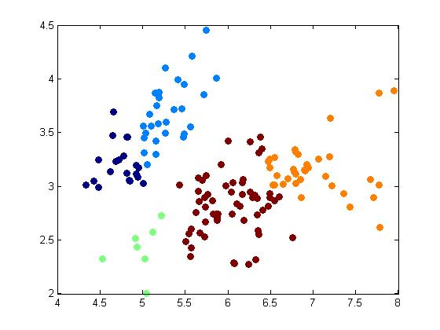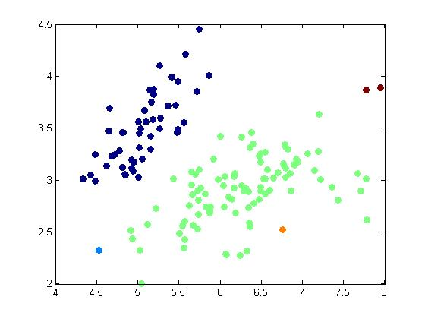

k=20;

% [z join] = agglomCluster(X,nClust,method,join)

% [z, join] = hcluster(X,K,method, [,join]) : perform heirarchical agglomerative clustering

% z = assignment of data into K clusters

% method = {'min','max,'means','average'} : cluster distance / linkage type (single,complete,mean,avg)

% join = sequence of joining operations performed by hcluster (pass to avoid re-clustering for new K)

[z] = agglomCluster(X,k,'max'); %'max' refer to complete

fig(1);

plotClassify2D([],X,z);

hold on;

% plot(c(:,1),c(:,2),'kx','markersize',14,'linewidth',3);

hold off;

The following plot referring to ‘max = complete’ and ‘min = single’ with k=20

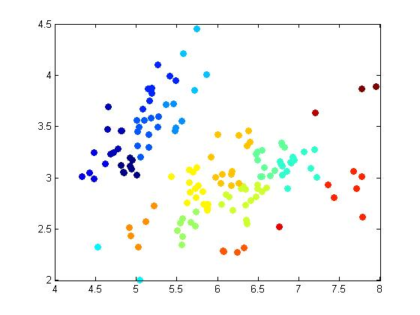

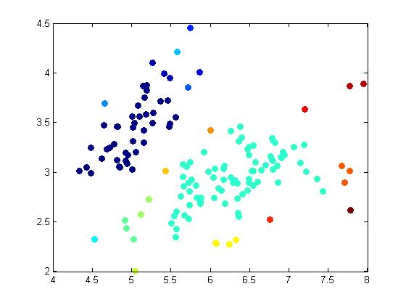

Problem 1 Part D

% [z,T,soft,ll] = emCluster(X,K,cInit,nIter,tol)z

%

% % [assign, clusters, soft, loglikelihd] = emCluster(X, K [,initialize,nIter,tol])

% % Perform Gaussian mixture EM clustering on data X (# data x # features)

% % initial clusters can be [K x N], or a method {'random', 'farthest', 'k++'}

% % random : K random data points (uniformly) as clusters;

% % farthest: choose cluster 1 uniformly, then the point farthest from all clusters so far, etc.

% % k++ : choose cluster 1 uniformly, then points randomly proportional to distance from current clusters

% % Returns:

% % assign (# data x 1) index of cluster

% % clusters (struct): wt (Kx1), mu (K x # features), sig(#feat,#nfeat,K) : Gaussian component parameters

% % soft (#data x K) : soft assignment probabilities (rounded for assign)

% % loglikelihd (scalar) log-likelihood of the data under the returned model

% % Returns after nIter iterations (default 100) or when converged to tolerance tol (default 1e-6)

% %

% % To convert clusters into a "clustering rule" that can be applied to future data, use the Gaussian Bayes methods:

% % (TODO)

K = 5;

tol = 1e-6;

[z,T,soft,ll] = emCluster(X,K,'k++',1,tol);

In this part, the code for method ‘k++’ is run with nIter = 1, 100 ,1000. Result are show in the following plot

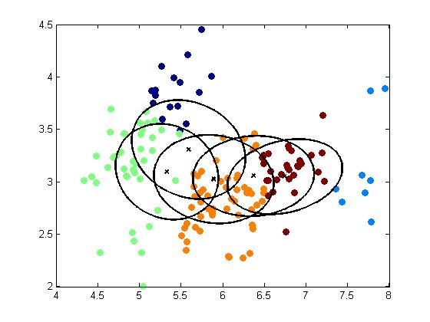

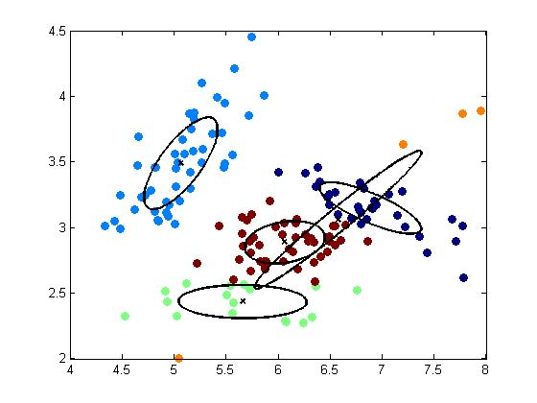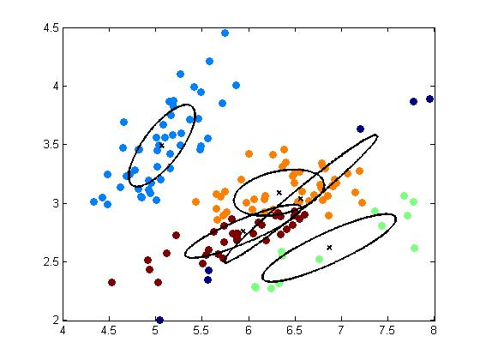

From figure two, which is a build in plot. It show convergence when nIter increase. The plot for nIter = 100,10000 are shown below.

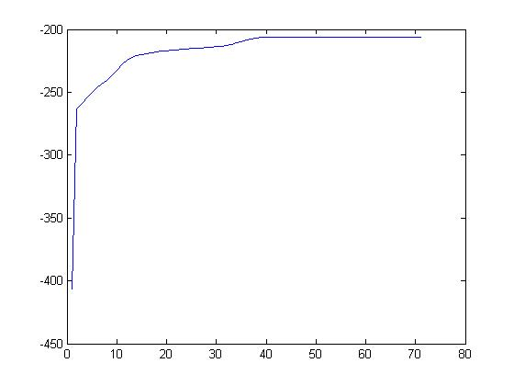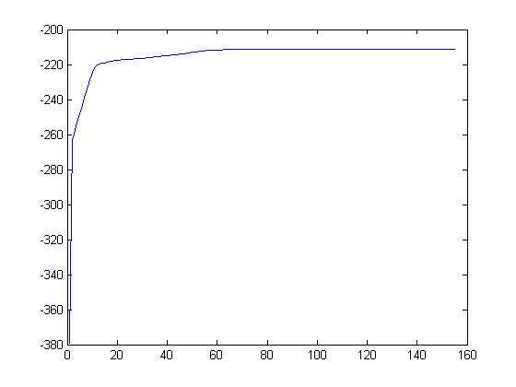

Consider the case that k = 20, with ‘method = k++’ Plot for nIter = 1, 100, 10000 are shown below

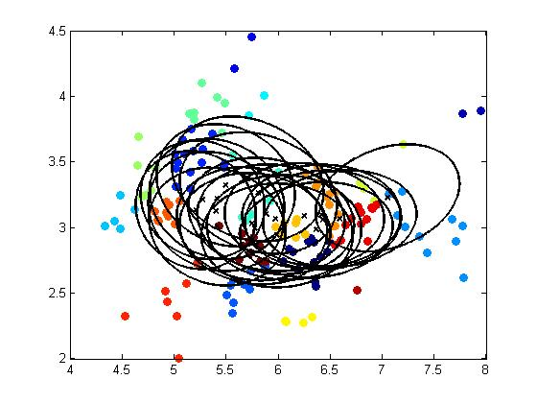

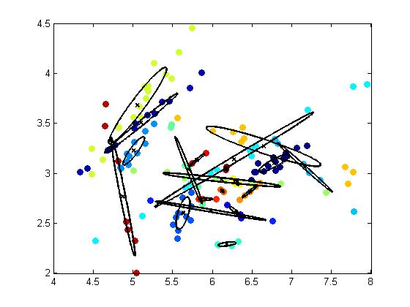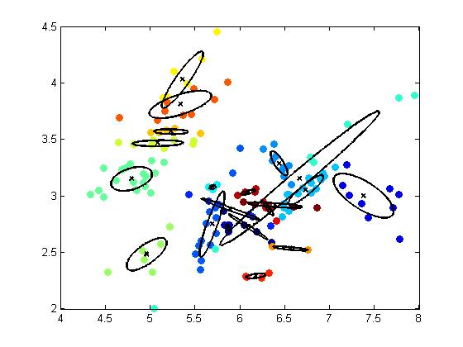

Figure 2 for nIter = 100 and 10000

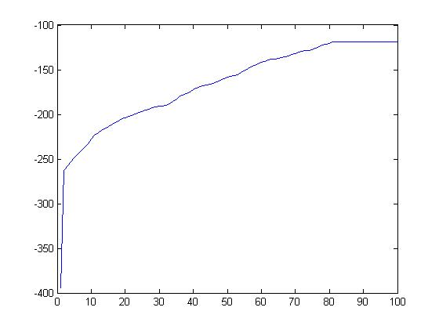

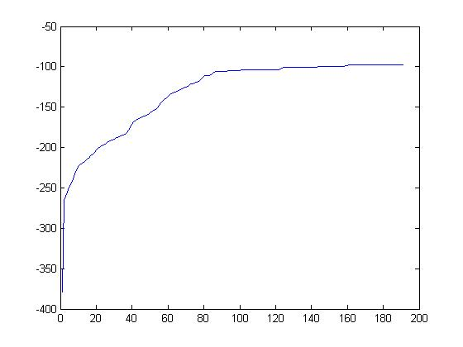

Compare EM to kmeans, EM allows clusters to overlap with each other while it doesn’t happen in kmeans. Difference may not be obvious with small number of clusters, but it become obvious when larger number of clusters is used.

Problem 2

Part A:

% Read in vocabulary and data (word counts per document)

[vocab] = textread('data/text/vocab.txt','%s');

[did,wid,cnt] = textread('data/text/docword.txt','%d%d%d','headerlines',3);

X = sparse(did,wid,cnt); % convert to a matlab sparse matrix

D = max(did); % number of docs

W = max(wid); % size of vocab

N = sum(cnt); % total number of words

% It is often helpful to normalize by the document length:

Xn= X./ repmat(sum(X,2),[1,W]) ; % divide word counts by doc length

k=20;

[idx,c,sumd] = kmeans(Xn,k,'farthest',100);

[idx1,c1,sumd1] = kmeans(Xn,k,'random',100);

[idx2,c2,sumd2] = kmeans(Xn,k,'k++',100);

sumd = 2.0211 ; sumd1 = 2.4083; sumd2 = 2.0375

Base on the number above, method ‘farthest’ provides the smallest error

**Part B**

Two methods were tested. The alternative method makes more sense. Therefore, it will be the final answer.

% Part B (Re-run kmeans clustering at least 4 more times, report the cost function)

i = 1;

if (i<=10)

[idx_b,c_b,sumd_b] = kmeans(Xn,k,'farthest',100);

[idx1_b,c1_b,sumd1_b] = kmeans(Xn,k,'random',100);

[idx2_b,c2_b,sumd2_b] = kmeans(Xn,k,'k++',100);

i= i+1;

end

% Alternative Part B

[z1, c1, sumd_alt1] = kmeans(Xn, 20);

[z2, c2, sumd_alt2] = kmeans(Xn, 20);

[z3, c3, sumd_alt3] = kmeans(Xn, 20);

[z4, c4, sumd_alt4] = kmeans(Xn, 20);

fprintf('sumd_alt1 = %g; sumd_alt2 = %g; sumd_alt3 = %g; sumd_alt4 = %g\n',sumd_alt1, sumd_alt2, sumd_alt3, sumd_alt4);

sumd_alt1 = 2.05827; sumd_alt2 = 2.41021; sumd_alt3 = 2.47781; sumd_alt4 = 2.45375

The best error: 2.05827

**Part C**

% Part C (How many articles (documents) are associated with each cluster)

% (Cluster is described by a vector in the feature space (word freq) =>

% print out the cluster center's ten "most likely" words)

% Do they form interpretable sets

k=20;

[idx,c,sumd] = kmeans(Xn,k,'farthest',100);

[idx1,c1,sumd1] = kmeans(Xn,k,'random',100);

[idx2,c2,sumd2] = kmeans(Xn,k,'k++',100);

% Returns:

% assign (# data x 1) index of cluster

% clusters (K x # features) cluster centers

% sumd (scalar) sum of squared euclidean distances

% Returns after nIter iterations (default 100) or when converged

% For each cluster (Here, it returns the count (i.e. number of elememts) in

% each cluster)

count1 = zeros(1,20); % count1 refer to count for kmeans (with 'farthest' initialzation

for i=1:20

count1(i) = sum(idx == i); % idx refer to 'assign (# data x 1) index of cluster'

end

count2 = zeros(1,20); % count2 refer to count for kmeans (with 'random' initialzation

for i=1:20

count2(i) = sum(idx1 == i);

end

count3 = zeros(1,20); % count3 refer to count for kmeans (with 'k++' initialzation

for i=1:20

count3(i) = sum(idx == i);

end

% output the 10 most common words in an article based on its features

[sorted,order] = sort(c(1,:),2,'descend');

fprintf('Ten "most likely" words for count1 %d: ', i);

fprintf('%s ',vocab{order(1:10)});

fprintf('\n');

[sorted,order] = sort(c1(1,:),2,'descend');

fprintf('Ten "most likely" words for count2 %d: ', i);

fprintf('%s ',vocab{order(1:10)});

fprintf('\n');

[sorted,order] = sort(c2(1,:),2,'descend');

fprintf('Ten "most likely" words for count3 %d: ', i);

fprintf('%s ',vocab{order(1:10)});

fprintf('\n');

count1=

161 1 2 2 1 1 1 3 1 1 1 2 4 3 4 1 1 2 1 9

count2=

1 1 2 11 2 1 1 2 97 2 39 1 2 1 1 5 10 14 8 1

count3=

161 1 2 2 1 1 1 3 1 1 1 2 4 3 4 1 1 2 1 9

**Ten "most likely" words for count1 20:**

team game city 2000 times millennium season york y2k century

**Ten "most likely" words for count2 20:**

news cnn abc hours millennium clinton midnight coverage entertainment friday

**Ten "most likely" words for count3 20:**

y2k 2000 problems koskinen saturday computers computer system problem reported

**Part D**

% Part D (Look at the cluster assignments for the documents, and _find the cluster(s) associated with

% documents 1, 15, and 30. For each of these clusters, find all the documents in that cluster (or

% at least 12 of them, if there are a lot) and print out the first several lines of each document.

% Do the documents form coherent groups? Based on the words you saw in the previous part,

% is this the best cluster for those documents?

k=20;

[idx,c,sumd] = kmeans(Xn,k,'farthest',100);

[idx1,c1,sumd1] = kmeans(Xn,k,'random',100);

[idx2,c2,sumd2] = kmeans(Xn,k,'k++',100);

% Returns:

% assign (# data x 1) index of cluster

% clusters (K x # features) cluster centers

% sumd (scalar) sum of squared euclidean distances

% Returns after nIter iterations (default 100) or when converged

cluster_assign_farthest_1 = idx(1);

cluster_assign_farthest_15 = idx(15);

cluster_assign_farthest_30 = idx(30);

cluster_assign_random_1 = idx1(1);

cluster_assign_random_15 = idx1(15);

cluster_assign_random_30 = idx1(30);

cluster_assign_kpp_1 = idx2(1);

cluster_assign_kpp_15 = idx2(15);

cluster_assign_kpp_30 = idx2(30);

% Find all document in these cluster

address_farthest_1 = find(idx == cluster_assign_farthest_1);

address_farthest_15 = find(idx == cluster_assign_farthest_15);

address_farthest_30 = find(idx == cluster_assign_farthest_30);

address_random_1 = find(idx == cluster_assign_random_1);

address_random_15 = find(idx == cluster_assign_random_15);

address_random_30 = find(idx == cluster_assign_random_30);

address_kpp_1 = find(idx == cluster_assign_kpp_1);

address_kpp_15 = find(idx == cluster_assign_kpp_15);

address_kpp_30 = find(idx == cluster_assign_kpp_30);

% Pick 12 document from each cluster

selected_doc_farthest_1 = datasample(address_farthest_1,12);

selected_doc_farthest_15 = datasample(address_farthest_15,12);

selected_doc_farthest_30 = datasample(address_farthest_15,12);

selected_doc_random_1 = datasample(address_random_1,12);

selected_doc_random_15 = datasample(address_random_15,12);

selected_doc_random_30 = datasample(address_random_30,12);

selected_doc_kpp_1 = datasample(address_kpp_1,12);

selected_doc_kpp_15 = datasample(address_kpp_15,12);

selected_doc_kpp_30 = datasample(address_kpp_30,12);

% View a snippet of the article (With 'farthest' method)

for j=1:12

i = selected_doc_farthest_1(j);

fname = sprintf('data/text/example1/20000101.%04d.txt',i);

txt = textread(fname, '%s', 10, 'whitespace', '\r\n');

fprintf('Doc_farthest_1 %d: ', j);

fprintf('%s\n', txt{:});

end

for j=1:12

i = selected_doc_farthest_15(j);

fname = sprintf('data/text/example1/20000101.%04d.txt',i);

txt = textread(fname, '%s', 10, 'whitespace', '\r\n');

fprintf('Doc_farthest_15 %d: ', j);

fprintf('%s\n', txt{:});

end

for j=1:12

i = selected_doc_farthest_30(j);

fname = sprintf('data/text/example1/20000101.%04d.txt',i);

txt = textread(fname, '%s', 10, 'whitespace', '\r\n');

fprintf('Doc_farthest_30 %d: ', j);

fprintf('%s\n', txt{:});

end

% View a snippet of the article (With 'random' method)

for j=1:12

i = selected_doc_random_1(j);

fname = sprintf('data/text/example1/20000101.%04d.txt',i);

txt = textread(fname, '%s', 10, 'whitespace', '\r\n');

fprintf('Doc_random_1 %d: ', j);

fprintf('%s\n', txt{:});

end

for j=1:12

i = selected_doc_random_15(j);

fname = sprintf('data/text/example1/20000101.%04d.txt',i);

txt = textread(fname, '%s', 10, 'whitespace', '\r\n');

fprintf('Doc_random_15 %d: ', j);

fprintf('%s\n', txt{:});

end

for j=1:12

i = selected_doc_random_30(j);

fname = sprintf('data/text/example1/20000101.%04d.txt',i);

txt = textread(fname, '%s', 10, 'whitespace', '\r\n');

fprintf('Doc_random_30 %d: ', j);

fprintf('%s\n', txt{:});

end

% View a snippet of the article (With 'kpp' method)

for j=1:12

i = selected_doc_kpp_1(j);

fname = sprintf('data/text/example1/20000101.%04d.txt',i);

txt = textread(fname, '%s', 10, 'whitespace', '\r\n');

fprintf('Doc_kpp_1 %d: ', j);

fprintf('%s\n', txt{:});

end

for j=1:12

i = selected_doc_kpp_15(j);

fname = sprintf('data/text/example1/20000101.%04d.txt',i);

txt = textread(fname, '%s', 10, 'whitespace', '\r\n');

fprintf('Doc_kpp_15 %d: ', j);

fprintf('%s\n', txt{:});

end

for j=1:12

i = selected_doc_kpp_30(j);

fname = sprintf('data/text/example1/20000101.%04d.txt',i);

txt = textread(fname, '%s', 10, 'whitespace', '\r\n');

fprintf('Doc_kpp_30 %d: ', j);

fprintf('%s\n', txt{:});

end

**Result:**

Doc_farthest_1 1: Always and forever a shooter, Brett Hull took aim again last

week, this time with his second most reliable weapon: his tongue.

Hull, now with 601 goals and inching closer to breaking his

father's career total of 610, said in a conference call Thursday

that ``the game isn't a whole bunch of fun to play anymore'' and

that he wishes the Lords of the Boards would make the moves

necessary to bring back the game's offense.

``I come to the rink every day,'' said the glib Hull, the NHL's

top goal scorer of the '90s (494 after a pair in the Dallas Stars'

5-4 victory over Anaheim Friday night) , ``hoping that it will

Doc_farthest_1 2: FOR SUNDAY, Jan. 2, 2000

c. 1999 Cox News Service

For questions, please call 404-526-5456

This is the Cox News Service sports budget for Sunday, Jan. 2.

It is the only scheduled sports budget.

If you have questions or need a resend, please call CoxNet, the

Cox News Service, at 404-526-5456. The night news editor, until 10

p.m. EDT, is Greg Laudick at 404-526-5456.

FOOTBALL/COLLEGE BOWLS

FBC-COTTONBOWL _ DALLAS _ Coverage of the Cotton Bowl _ Texas

Doc_farthest_1 3: Bengals receiver Carl Pickens criticized owner and

general manager Mike Brown, who last week decided to keep coach

Bruce Coslet for at least one more season.

``I don't understand it,'' Pickens said. ``We're trying to win.

We're trying to turn this thing around out there. And they bring

him back. What can you do? Obviously, the players don't call the

shots around here.''

Pickens later issued a statement retracting his comments, but

the damage seemed to be done.

``I learned a long time ago you can't please everybody,'' Coslet

Doc_farthest_1 4: Ronnie Lott spent nine years with the San Francisco 49ers and

earned a reputation as one of the best safeties ever to play the

game. No one was more fearless as a player, or more respected by

his peers. Quite simply, he helped change the fortunes of the

franchise, earning five Super Bowl rings.

Now, Lott says he is hoping to change the way the NFL Players

Association does business and is strongly considering a run to

replace its longtime executive director, Gene Upshaw.

If Lott does run, it will represent the first significant

challenge Upshaw has faced, because Lott is held in such high

Doc_farthest_1 5: Who could know?

Oh, they had a hunch when he came out of high school, with lots

of schools chasing him. But he was still more a development for the

new millennium than something you could count on right away.

Which is why his coach chose to redshirt him last year and let

him season from the sideline.

Even when this season started, there was all that talk of

potential. ``We had a plan,'' said his offensive coordinator. ``But

I didn't know how he would play or how he would run. I knew he was

going to make a lot of big plays. I just hoped it would be for us.

Doc_farthest_1 6: For Peter Warrick, Tuesday night's Sugar Bowl game

represents nothing less than a fight for his legacy at Florida

State.

To put it bluntly: Will Warrick be remembered as the guy who

made a mistake and lost the Heisman Trophy? Or will he be the

player who helped Florida State win its second national

championship?

To Warrick, those will be the stakes when the No. 1 Seminoles

take on No. 2 Virginia Tech at the Super Dome.

``This is my last shot to prove what I can do in college ball,''

Doc_farthest_1 7: Instead of 1-10-10, Texas should have had a different motto _

9-1-1. Only emergency assistance could have saved the Longhorns

from the Arkansas Razorbacks on Saturday in the first meeting

between the former rivals in more than eight years.

A dominating Arkansas defense and several big plays by the Hogs'

offense in the second half enabled the 24th-ranked Razorbacks to

earn a convincing 27-6 victory over 14th-ranked Texas in front of

72,723 spectators.

``Today we played with a lot of emotion, passion and fanatical

effort,'' said Arkansas coach Houston Nutt. ``After ending the

Doc_farthest_1 8: Who could know?

Oh, they had a hunch when he came out of high school, with lots

of schools chasing him. But he was still more a development for the

new millennium than something you could count on right away.

Which is why his coach chose to redshirt him last year and let

him season from the sideline.

Even when this season started, there was all that talk of

potential. ``We had a plan,'' said his offensive coordinator. ``But

I didn't know how he would play or how he would run. I knew he was

going to make a lot of big plays. I just hoped it would be for us.

Doc_farthest_1 9: Basketball players added muscles and multimillion-dollar sneaker

contracts. American yachts lost the America's Cup, gained it back,

then lost it again. Grass all but disappeared on tennis courts. The

natural stuff almost became extinct in baseball and football before

injuries and nostalgia spurred its comeback. Lights finally shone

at Wrigley Field. Europe became a major talent pool for the

National Hockey League; golf and tennis benefited from America's

diversity. What could happen next, on and off the field? A look at

nine sports.

Auto Racing

Doc_farthest_1 10: Ronnie Lott spent nine years with the San Francisco 49ers and

earned a reputation as one of the best safeties ever to play the

game. No one was more fearless as a player, or more respected by

his peers. Quite simply, he helped change the fortunes of the

franchise, earning five Super Bowl rings.

Now, Lott says he is hoping to change the way the NFL Players

Association does business and is strongly considering a run to

replace its longtime executive director, Gene Upshaw.

If Lott does run, it will represent the first significant

challenge Upshaw has faced, because Lott is held in such high

Doc_farthest_1 11: Lakers Grow Up, Learn How to

Win _ that not even Phil Jackson is buying it until the postseason

begins. But in his first year with Shaquille O'Neal and Kobe

Bryant, Jackson has gotten the Lakers to buy into a defensive

philosophy that may pay huge dividends in a few months.

There is a reason the Lakers won their 10th straight game last

week, have won 17 of their last 18 and at 25-5 possess the best

record in the NBA. It is not the triangle offense as much as it is

a collapsing defense that has taken ammunition from some of the

league's top guns.

Doc_farthest_1 12: Come Feb. 13, at least one member of the Los

Angeles Lakers might be a reluctant All-Star.

Phil Jackson is leading the race for coach of the Western

Conference All-Star team, by virtue of the Lakers' best-in-the-West

record. But it's not an honor he covets, to say the least.

``I dislike the whole venture,'' he said Saturday. ``I dislike

the concept. I like baseball's All-Star game that's an individual

sport, where you just go out and a guy hits against the pitcher. .

. . But basketball, I don't like it at all.''

Jackson said the NBA All-Star game encourages ``all the wrong

Doc_farthest_15 1: Despite a few sputters and glitches, the world's computers

appear to have survived the Year 2000 rollover without major

problems _ and with humanity's faith in technology intact, at least

for another day.

As clocks passed midnight around the world, there were a flurry

of reports of apparently minor prob- lems: a timing device at a

electric plant in Wisconsin jumped ahead 35 days, but it was

quickly reset; a monitoring system at a Japanese nuclear plant

malfunctioned, but it did not affect the operation of the reactor;

in Australia, ticketing ma- chines on some buses jammed.

Doc_farthest_15 2: Now that the Year 2000 has arrived around the world without

significant disruptions of power, transportation, commerce and

other activities dependent on computers, the question arises: Was

the threat of technology failure overstated, or was it all those

hundreds of billions of dollars that were spent to fix things that

prevented a catastrophe?

Most computer experts insist that the problem was a widespread

and major threat before work began. ``There was puffery by vendors

and some money was wasted, but these were real problems,'' said

Leon Kappelman, a University of North Texas associate professor of

Doc_farthest_15 3: A stockpile of $750,000 worth of spare parts set

aside for Year 2000 fixes remained in a storeroom Saturday in New

York City's computer center in Brooklyn.

The only power failure associated with the transition to 2000

came when a foil balloon in Queens rose and struck some wires,

blacking out 100 customers, utility officials said.

City officials said it was too early to say that no computer

repairs would be needed, with systems of lesser importance

scheduled to kick on in the days ahead. But they emphasized that

globally, it was increasingly evident that something remarkable had

Doc_farthest_15 4: Now that the Year 2000 has arrived around the world without

significant disruptions of power, transportation, commerce and

other activities dependent on computers, the question arises: Was

the threat of technology failure overstated, or was it all those

hundreds of billions of dollars that were spent to fix things that

prevented a catastrophe?

Most computer experts insist that the problem was a widespread

and major threat before work began. ``There was puffery by vendors

and some money was wasted, but these were real problems,'' said

Leon Kappelman, a University of North Texas associate professor of

Doc_farthest_15 5: Now that the Year 2000 has arrived around the world without

significant disruptions of power, transportation, commerce and

other activities dependent on computers, the question arises: Was

the threat of technology failure overstated, or was it all those

hundreds of billions of dollars that were spent to fix things that

prevented a catastrophe?

Most computer experts insist that the problem was a widespread

and major threat before work began. ``There was puffery by vendors

and some money was wasted, but these were real problems,'' said

Leon Kappelman, a University of North Texas associate professor of

Doc_farthest_15 6: A stockpile of $750,000 worth of spare parts set

aside for Year 2000 fixes remained in a storeroom Saturday in New

York City's computer center in Brooklyn.

The only power failure associated with the transition to 2000

came when a foil balloon in Queens rose and struck some wires,

blacking out 100 customers, utility officials said.

City officials said it was too early to say that no computer

repairs would be needed, with systems of lesser importance

scheduled to kick on in the days ahead. But they emphasized that

globally, it was increasingly evident that something remarkable had

Doc_farthest_15 7: A stockpile of $750,000 worth of spare parts set

aside for Year 2000 fixes remained in a storeroom Saturday in New

York City's computer center in Brooklyn.

The only power failure associated with the transition to 2000

came when a foil balloon in Queens rose and struck some wires,

blacking out 100 customers, utility officials said.

City officials said it was too early to say that no computer

repairs would be needed, with systems of lesser importance

scheduled to kick on in the days ahead. But they emphasized that

globally, it was increasingly evident that something remarkable had

Doc_farthest_15 8: Now that the Year 2000 has arrived around the world without

significant disruptions of power, transportation, commerce and

other activities dependent on computers, the question arises: Was

the threat of technology failure overstated, or was it all those

hundreds of billions of dollars that were spent to fix things that

prevented a catastrophe?

Most computer experts insist that the problem was a widespread

and major threat before work began. ``There was puffery by vendors

and some money was wasted, but these were real problems,'' said

Leon Kappelman, a University of North Texas associate professor of

Doc_farthest_15 9: A stockpile of $750,000 worth of spare parts set

aside for Year 2000 fixes remained in a storeroom Saturday in New

York City's computer center in Brooklyn.

The only power failure associated with the transition to 2000

came when a foil balloon in Queens rose and struck some wires,

blacking out 100 customers, utility officials said.

City officials said it was too early to say that no computer

repairs would be needed, with systems of lesser importance

scheduled to kick on in the days ahead. But they emphasized that

globally, it was increasingly evident that something remarkable had

Doc_farthest_15 10: Despite a few sputters and glitches, the world's computers

appear to have survived the Year 2000 rollover without major

problems _ and with humanity's faith in technology intact, at least

for another day.

As clocks passed midnight around the world, there were a flurry

of reports of apparently minor prob- lems: a timing device at a

electric plant in Wisconsin jumped ahead 35 days, but it was

quickly reset; a monitoring system at a Japanese nuclear plant

malfunctioned, but it did not affect the operation of the reactor;

in Australia, ticketing ma- chines on some buses jammed.

Doc_farthest_15 11: Despite a few sputters and glitches, the world's computers

appear to have survived the Year 2000 rollover without major

problems _ and with humanity's faith in technology intact, at least

for another day.

As clocks passed midnight around the world, there were a flurry

of reports of apparently minor prob- lems: a timing device at a

electric plant in Wisconsin jumped ahead 35 days, but it was

quickly reset; a monitoring system at a Japanese nuclear plant

malfunctioned, but it did not affect the operation of the reactor;

in Australia, ticketing ma- chines on some buses jammed.

Doc_farthest_15 12: Now that the Year 2000 has arrived around the world without

significant disruptions of power, transportation, commerce and

other activities dependent on computers, the question arises: Was

the threat of technology failure overstated, or was it all those

hundreds of billions of dollars that were spent to fix things that

prevented a catastrophe?

Most computer experts insist that the problem was a widespread

and major threat before work began. ``There was puffery by vendors

and some money was wasted, but these were real problems,'' said

Leon Kappelman, a University of North Texas associate professor of

Doc_farthest_30 1: A stockpile of $750,000 worth of spare parts set

aside for Year 2000 fixes remained in a storeroom Saturday in New

York City's computer center in Brooklyn.

The only power failure associated with the transition to 2000

came when a foil balloon in Queens rose and struck some wires,

blacking out 100 customers, utility officials said.

City officials said it was too early to say that no computer

repairs would be needed, with systems of lesser importance

scheduled to kick on in the days ahead. But they emphasized that

globally, it was increasingly evident that something remarkable had

Doc_farthest_30 2: Now that the Year 2000 has arrived around the world without

significant disruptions of power, transportation, commerce and

other activities dependent on computers, the question arises: Was

the threat of technology failure overstated, or was it all those

hundreds of billions of dollars that were spent to fix things that

prevented a catastrophe?

Most computer experts insist that the problem was a widespread

and major threat before work began. ``There was puffery by vendors

and some money was wasted, but these were real problems,'' said

Leon Kappelman, a University of North Texas associate professor of

Doc_farthest_30 3: Now that the Year 2000 has arrived around the world without

significant disruptions of power, transportation, commerce and

other activities dependent on computers, the question arises: Was

the threat of technology failure overstated, or was it all those

hundreds of billions of dollars that were spent to fix things that

prevented a catastrophe?

Most computer experts insist that the problem was a widespread

and major threat before work began. ``There was puffery by vendors

and some money was wasted, but these were real problems,'' said

Leon Kappelman, a University of North Texas associate professor of

Doc_farthest_30 4: A stockpile of $750,000 worth of spare parts set

aside for Year 2000 fixes remained in a storeroom Saturday in New

York City's computer center in Brooklyn.

The only power failure associated with the transition to 2000

came when a foil balloon in Queens rose and struck some wires,

blacking out 100 customers, utility officials said.

City officials said it was too early to say that no computer

repairs would be needed, with systems of lesser importance

scheduled to kick on in the days ahead. But they emphasized that

globally, it was increasingly evident that something remarkable had

Doc_farthest_30 5: Despite a few sputters and glitches, the world's computers

appear to have survived the Year 2000 rollover without major

problems _ and with humanity's faith in technology intact, at least

for another day.

As clocks passed midnight around the world, there were a flurry

of reports of apparently minor prob- lems: a timing device at a

electric plant in Wisconsin jumped ahead 35 days, but it was

quickly reset; a monitoring system at a Japanese nuclear plant

malfunctioned, but it did not affect the operation of the reactor;

in Australia, ticketing ma- chines on some buses jammed.

Doc_farthest_30 6: Now that the Year 2000 has arrived around the world without

significant disruptions of power, transportation, commerce and

other activities dependent on computers, the question arises: Was

the threat of technology failure overstated, or was it all those

hundreds of billions of dollars that were spent to fix things that

prevented a catastrophe?

Most computer experts insist that the problem was a widespread

and major threat before work began. ``There was puffery by vendors

and some money was wasted, but these were real problems,'' said

Leon Kappelman, a University of North Texas associate professor of

Doc_farthest_30 7: Now that the Year 2000 has arrived around the world without

significant disruptions of power, transportation, commerce and

other activities dependent on computers, the question arises: Was

the threat of technology failure overstated, or was it all those

hundreds of billions of dollars that were spent to fix things that

prevented a catastrophe?

Most computer experts insist that the problem was a widespread

and major threat before work began. ``There was puffery by vendors

and some money was wasted, but these were real problems,'' said

Leon Kappelman, a University of North Texas associate professor of

Doc_farthest_30 8: Despite a few sputters and glitches, the world's computers

appear to have survived the Year 2000 rollover without major

problems _ and with humanity's faith in technology intact, at least

for another day.

As clocks passed midnight around the world, there were a flurry

of reports of apparently minor prob- lems: a timing device at a

electric plant in Wisconsin jumped ahead 35 days, but it was

quickly reset; a monitoring system at a Japanese nuclear plant

malfunctioned, but it did not affect the operation of the reactor;

in Australia, ticketing ma- chines on some buses jammed.

Doc_farthest_30 9: Now that the Year 2000 has arrived around the world without

significant disruptions of power, transportation, commerce and

other activities dependent on computers, the question arises: Was

the threat of technology failure overstated, or was it all those

hundreds of billions of dollars that were spent to fix things that

prevented a catastrophe?

Most computer experts insist that the problem was a widespread

and major threat before work began. ``There was puffery by vendors

and some money was wasted, but these were real problems,'' said

Leon Kappelman, a University of North Texas associate professor of

Doc_farthest_30 10: A stockpile of $750,000 worth of spare parts set

aside for Year 2000 fixes remained in a storeroom Saturday in New

York City's computer center in Brooklyn.

The only power failure associated with the transition to 2000

came when a foil balloon in Queens rose and struck some wires,

blacking out 100 customers, utility officials said.

City officials said it was too early to say that no computer

repairs would be needed, with systems of lesser importance

scheduled to kick on in the days ahead. But they emphasized that

globally, it was increasingly evident that something remarkable had

Doc_farthest_30 11: Now that the Year 2000 has arrived around the world without

significant disruptions of power, transportation, commerce and

other activities dependent on computers, the question arises: Was

the threat of technology failure overstated, or was it all those

hundreds of billions of dollars that were spent to fix things that

prevented a catastrophe?

Most computer experts insist that the problem was a widespread

and major threat before work began. ``There was puffery by vendors

and some money was wasted, but these were real problems,'' said

Leon Kappelman, a University of North Texas associate professor of

Doc_farthest_30 12: A stockpile of $750,000 worth of spare parts set

aside for Year 2000 fixes remained in a storeroom Saturday in New

York City's computer center in Brooklyn.

The only power failure associated with the transition to 2000

came when a foil balloon in Queens rose and struck some wires,

blacking out 100 customers, utility officials said.

City officials said it was too early to say that no computer

repairs would be needed, with systems of lesser importance

scheduled to kick on in the days ahead. But they emphasized that

globally, it was increasingly evident that something remarkable had

Doc_random_1 1: THIRD MILLENNIUM CELEBRATIONS CAST LIGHT ON TWO MEXICOS

By FRANC CONTRERAS

c.1999 Special to the Cox News Service

OAXACA CITY, Mexico _ While most of Mexico welcomed the Third

Millennium with fireworks, concerts and long-standing traditions,

the celebration was muted in rural areas by fear of rebel attacks

and the so-called Y2K bug's negative impact on tourism.

All across Mexico and here, in this well-known colonial city,

families joined together for traditional New Year's Eve supper and

counted down to mid-night wearing red underwear, which they believe

Doc_random_1 2: THIRD MILLENNIUM CELEBRATIONS CAST LIGHT ON TWO MEXICOS

By FRANC CONTRERAS

c.1999 Special to the Cox News Service

OAXACA CITY, Mexico _ While most of Mexico welcomed the Third

Millennium with fireworks, concerts and long-standing traditions,

the celebration was muted in rural areas by fear of rebel attacks

and the so-called Y2K bug's negative impact on tourism.

All across Mexico and here, in this well-known colonial city,

families joined together for traditional New Year's Eve supper and

counted down to mid-night wearing red underwear, which they believe

Doc_random_1 3: THIRD MILLENNIUM CELEBRATIONS CAST LIGHT ON TWO MEXICOS

By FRANC CONTRERAS

c.1999 Special to the Cox News Service

OAXACA CITY, Mexico _ While most of Mexico welcomed the Third

Millennium with fireworks, concerts and long-standing traditions,

the celebration was muted in rural areas by fear of rebel attacks

and the so-called Y2K bug's negative impact on tourism.

All across Mexico and here, in this well-known colonial city,

families joined together for traditional New Year's Eve supper and

counted down to mid-night wearing red underwear, which they believe

Doc_random_1 4: What the Russian troops have to do in Grozny is certainly a

dangerous job. In Moscow, Russian spokesmen have promised that the

troops will not ``storm'' Grozny, an allusion to the first war in

Chechnya, when a Russian armor column zoomed into the center of the

city on New Year's Eve in 1994 and was quickly annihilated.

Instead, they assert, Russian troops are conducting a ``special

operation'' to take the city, implying that sophisticated tactics

are being used to keep Russian losses to a minimum.

In reality, Russian troops say they are involved in messy urban

warfare with heavily armed, experienced and motivated rebels.

Doc_random_1 5: When he is asked about the fighting in

Grozny, Konstantin Kukhlovets shows the red splotch on his index

finger. The 24-year-old lieutenant said he was firing his machine

gun so furiously that he was scalded by the heat of the gun barrel.

Three of his men were wounded in a 10-minute firefight, and

Kukhlovets says his entire unit might have been annihilated if they

had tried to fight their way into the center of the city against

entrenched Chechen rebels.

``We have been fighting all over Chechnya, but Grozny is the

first place we have come across such intense resistance,'' he said

Doc_random_1 6: THIRD MILLENNIUM CELEBRATIONS CAST LIGHT ON TWO MEXICOS

By FRANC CONTRERAS

c.1999 Special to the Cox News Service

OAXACA CITY, Mexico _ While most of Mexico welcomed the Third

Millennium with fireworks, concerts and long-standing traditions,

the celebration was muted in rural areas by fear of rebel attacks

and the so-called Y2K bug's negative impact on tourism.

All across Mexico and here, in this well-known colonial city,

families joined together for traditional New Year's Eve supper and

counted down to mid-night wearing red underwear, which they believe

Doc_random_1 7: What the Russian troops have to do in Grozny is certainly a

dangerous job. In Moscow, Russian spokesmen have promised that the

troops will not ``storm'' Grozny, an allusion to the first war in

Chechnya, when a Russian armor column zoomed into the center of the

city on New Year's Eve in 1994 and was quickly annihilated.

Instead, they assert, Russian troops are conducting a ``special

operation'' to take the city, implying that sophisticated tactics

are being used to keep Russian losses to a minimum.

In reality, Russian troops say they are involved in messy urban

warfare with heavily armed, experienced and motivated rebels.

Doc_random_1 8: When he is asked about the fighting in

Grozny, Konstantin Kukhlovets shows the red splotch on his index

finger. The 24-year-old lieutenant said he was firing his machine

gun so furiously that he was scalded by the heat of the gun barrel.

Three of his men were wounded in a 10-minute firefight, and

Kukhlovets says his entire unit might have been annihilated if they

had tried to fight their way into the center of the city against

entrenched Chechen rebels.

``We have been fighting all over Chechnya, but Grozny is the

first place we have come across such intense resistance,'' he said

Doc_random_1 9: What the Russian troops have to do in Grozny is certainly a

dangerous job. In Moscow, Russian spokesmen have promised that the

troops will not ``storm'' Grozny, an allusion to the first war in

Chechnya, when a Russian armor column zoomed into the center of the

city on New Year's Eve in 1994 and was quickly annihilated.

Instead, they assert, Russian troops are conducting a ``special

operation'' to take the city, implying that sophisticated tactics

are being used to keep Russian losses to a minimum.

In reality, Russian troops say they are involved in messy urban

warfare with heavily armed, experienced and motivated rebels.

Doc_random_1 10: What the Russian troops have to do in Grozny is certainly a

dangerous job. In Moscow, Russian spokesmen have promised that the

troops will not ``storm'' Grozny, an allusion to the first war in

Chechnya, when a Russian armor column zoomed into the center of the

city on New Year's Eve in 1994 and was quickly annihilated.

Instead, they assert, Russian troops are conducting a ``special

operation'' to take the city, implying that sophisticated tactics

are being used to keep Russian losses to a minimum.

In reality, Russian troops say they are involved in messy urban

warfare with heavily armed, experienced and motivated rebels.

Doc_random_1 11: When he is asked about the fighting in

Grozny, Konstantin Kukhlovets shows the red splotch on his index

finger. The 24-year-old lieutenant said he was firing his machine

gun so furiously that he was scalded by the heat of the gun barrel.

Three of his men were wounded in a 10-minute firefight, and

Kukhlovets says his entire unit might have been annihilated if they

had tried to fight their way into the center of the city against

entrenched Chechen rebels.

``We have been fighting all over Chechnya, but Grozny is the

first place we have come across such intense resistance,'' he said

Doc_random_1 12: When he is asked about the fighting in

Grozny, Konstantin Kukhlovets shows the red splotch on his index

finger. The 24-year-old lieutenant said he was firing his machine

gun so furiously that he was scalded by the heat of the gun barrel.

Three of his men were wounded in a 10-minute firefight, and

Kukhlovets says his entire unit might have been annihilated if they

had tried to fight their way into the center of the city against

entrenched Chechen rebels.

``We have been fighting all over Chechnya, but Grozny is the

first place we have come across such intense resistance,'' he said

Doc_random_15 1: THIRD MILLENNIUM CELEBRATIONS CAST LIGHT ON TWO MEXICOS

By FRANC CONTRERAS

c.1999 Special to the Cox News Service

OAXACA CITY, Mexico _ While most of Mexico welcomed the Third

Millennium with fireworks, concerts and long-standing traditions,

the celebration was muted in rural areas by fear of rebel attacks

and the so-called Y2K bug's negative impact on tourism.

All across Mexico and here, in this well-known colonial city,

families joined together for traditional New Year's Eve supper and

counted down to mid-night wearing red underwear, which they believe

Doc_random_15 2: THIRD MILLENNIUM CELEBRATIONS CAST LIGHT ON TWO MEXICOS

By FRANC CONTRERAS

c.1999 Special to the Cox News Service

OAXACA CITY, Mexico _ While most of Mexico welcomed the Third

Millennium with fireworks, concerts and long-standing traditions,

the celebration was muted in rural areas by fear of rebel attacks

and the so-called Y2K bug's negative impact on tourism.

All across Mexico and here, in this well-known colonial city,

families joined together for traditional New Year's Eve supper and

counted down to mid-night wearing red underwear, which they believe

Doc_random_15 3: THIRD MILLENNIUM CELEBRATIONS CAST LIGHT ON TWO MEXICOS

By FRANC CONTRERAS

c.1999 Special to the Cox News Service

OAXACA CITY, Mexico _ While most of Mexico welcomed the Third

Millennium with fireworks, concerts and long-standing traditions,

the celebration was muted in rural areas by fear of rebel attacks

and the so-called Y2K bug's negative impact on tourism.

All across Mexico and here, in this well-known colonial city,

families joined together for traditional New Year's Eve supper and

counted down to mid-night wearing red underwear, which they believe

Doc_random_15 4: When he is asked about the fighting in

Grozny, Konstantin Kukhlovets shows the red splotch on his index

finger. The 24-year-old lieutenant said he was firing his machine

gun so furiously that he was scalded by the heat of the gun barrel.

Three of his men were wounded in a 10-minute firefight, and

Kukhlovets says his entire unit might have been annihilated if they

had tried to fight their way into the center of the city against

entrenched Chechen rebels.

``We have been fighting all over Chechnya, but Grozny is the

first place we have come across such intense resistance,'' he said

Doc_random_15 5: THIRD MILLENNIUM CELEBRATIONS CAST LIGHT ON TWO MEXICOS

By FRANC CONTRERAS

c.1999 Special to the Cox News Service

OAXACA CITY, Mexico _ While most of Mexico welcomed the Third

Millennium with fireworks, concerts and long-standing traditions,

the celebration was muted in rural areas by fear of rebel attacks

and the so-called Y2K bug's negative impact on tourism.

All across Mexico and here, in this well-known colonial city,

families joined together for traditional New Year's Eve supper and

counted down to mid-night wearing red underwear, which they believe

Doc_random_15 6: When he is asked about the fighting in

Grozny, Konstantin Kukhlovets shows the red splotch on his index

finger. The 24-year-old lieutenant said he was firing his machine

gun so furiously that he was scalded by the heat of the gun barrel.

Three of his men were wounded in a 10-minute firefight, and

Kukhlovets says his entire unit might have been annihilated if they

had tried to fight their way into the center of the city against

entrenched Chechen rebels.

``We have been fighting all over Chechnya, but Grozny is the

first place we have come across such intense resistance,'' he said

Doc_random_15 7: When he is asked about the fighting in

Grozny, Konstantin Kukhlovets shows the red splotch on his index

finger. The 24-year-old lieutenant said he was firing his machine

gun so furiously that he was scalded by the heat of the gun barrel.

Three of his men were wounded in a 10-minute firefight, and

Kukhlovets says his entire unit might have been annihilated if they

had tried to fight their way into the center of the city against

entrenched Chechen rebels.

``We have been fighting all over Chechnya, but Grozny is the

first place we have come across such intense resistance,'' he said

Doc_random_15 8: THIRD MILLENNIUM CELEBRATIONS CAST LIGHT ON TWO MEXICOS

By FRANC CONTRERAS

c.1999 Special to the Cox News Service

OAXACA CITY, Mexico _ While most of Mexico welcomed the Third

Millennium with fireworks, concerts and long-standing traditions,

the celebration was muted in rural areas by fear of rebel attacks

and the so-called Y2K bug's negative impact on tourism.

All across Mexico and here, in this well-known colonial city,

families joined together for traditional New Year's Eve supper and

counted down to mid-night wearing red underwear, which they believe

Doc_random_15 9: THIRD MILLENNIUM CELEBRATIONS CAST LIGHT ON TWO MEXICOS

By FRANC CONTRERAS

c.1999 Special to the Cox News Service

OAXACA CITY, Mexico _ While most of Mexico welcomed the Third

Millennium with fireworks, concerts and long-standing traditions,

the celebration was muted in rural areas by fear of rebel attacks

and the so-called Y2K bug's negative impact on tourism.

All across Mexico and here, in this well-known colonial city,

families joined together for traditional New Year's Eve supper and

counted down to mid-night wearing red underwear, which they believe

Doc_random_15 10: What the Russian troops have to do in Grozny is certainly a

dangerous job. In Moscow, Russian spokesmen have promised that the

troops will not ``storm'' Grozny, an allusion to the first war in

Chechnya, when a Russian armor column zoomed into the center of the

city on New Year's Eve in 1994 and was quickly annihilated.

Instead, they assert, Russian troops are conducting a ``special

operation'' to take the city, implying that sophisticated tactics

are being used to keep Russian losses to a minimum.

In reality, Russian troops say they are involved in messy urban

warfare with heavily armed, experienced and motivated rebels.

Doc_random_15 11: When he is asked about the fighting in

Grozny, Konstantin Kukhlovets shows the red splotch on his index

finger. The 24-year-old lieutenant said he was firing his machine

gun so furiously that he was scalded by the heat of the gun barrel.

Three of his men were wounded in a 10-minute firefight, and

Kukhlovets says his entire unit might have been annihilated if they

had tried to fight their way into the center of the city against

entrenched Chechen rebels.

``We have been fighting all over Chechnya, but Grozny is the

first place we have come across such intense resistance,'' he said

Doc_random_15 12: THIRD MILLENNIUM CELEBRATIONS CAST LIGHT ON TWO MEXICOS

By FRANC CONTRERAS

c.1999 Special to the Cox News Service

OAXACA CITY, Mexico _ While most of Mexico welcomed the Third

Millennium with fireworks, concerts and long-standing traditions,

the celebration was muted in rural areas by fear of rebel attacks

and the so-called Y2K bug's negative impact on tourism.

All across Mexico and here, in this well-known colonial city,

families joined together for traditional New Year's Eve supper and

counted down to mid-night wearing red underwear, which they believe

Doc_random_30 1: When he is asked about the fighting in

Grozny, Konstantin Kukhlovets shows the red splotch on his index

finger. The 24-year-old lieutenant said he was firing his machine

gun so furiously that he was scalded by the heat of the gun barrel.

Three of his men were wounded in a 10-minute firefight, and

Kukhlovets says his entire unit might have been annihilated if they

had tried to fight their way into the center of the city against

entrenched Chechen rebels.

``We have been fighting all over Chechnya, but Grozny is the

first place we have come across such intense resistance,'' he said

Doc_random_30 2: THIRD MILLENNIUM CELEBRATIONS CAST LIGHT ON TWO MEXICOS

By FRANC CONTRERAS

c.1999 Special to the Cox News Service

OAXACA CITY, Mexico _ While most of Mexico welcomed the Third

Millennium with fireworks, concerts and long-standing traditions,

the celebration was muted in rural areas by fear of rebel attacks

and the so-called Y2K bug's negative impact on tourism.

All across Mexico and here, in this well-known colonial city,

families joined together for traditional New Year's Eve supper and

counted down to mid-night wearing red underwear, which they believe

Doc_random_30 3: THIRD MILLENNIUM CELEBRATIONS CAST LIGHT ON TWO MEXICOS

By FRANC CONTRERAS

c.1999 Special to the Cox News Service

OAXACA CITY, Mexico _ While most of Mexico welcomed the Third

Millennium with fireworks, concerts and long-standing traditions,

the celebration was muted in rural areas by fear of rebel attacks

and the so-called Y2K bug's negative impact on tourism.

All across Mexico and here, in this well-known colonial city,

families joined together for traditional New Year's Eve supper and

counted down to mid-night wearing red underwear, which they believe

Doc_random_30 4: What the Russian troops have to do in Grozny is certainly a

dangerous job. In Moscow, Russian spokesmen have promised that the

troops will not ``storm'' Grozny, an allusion to the first war in

Chechnya, when a Russian armor column zoomed into the center of the

city on New Year's Eve in 1994 and was quickly annihilated.

Instead, they assert, Russian troops are conducting a ``special

operation'' to take the city, implying that sophisticated tactics

are being used to keep Russian losses to a minimum.

In reality, Russian troops say they are involved in messy urban

warfare with heavily armed, experienced and motivated rebels.

Doc_random_30 5: When he is asked about the fighting in

Grozny, Konstantin Kukhlovets shows the red splotch on his index

finger. The 24-year-old lieutenant said he was firing his machine

gun so furiously that he was scalded by the heat of the gun barrel.

Three of his men were wounded in a 10-minute firefight, and

Kukhlovets says his entire unit might have been annihilated if they

had tried to fight their way into the center of the city against

entrenched Chechen rebels.

``We have been fighting all over Chechnya, but Grozny is the

first place we have come across such intense resistance,'' he said

Doc_random_30 6: When he is asked about the fighting in

Grozny, Konstantin Kukhlovets shows the red splotch on his index

finger. The 24-year-old lieutenant said he was firing his machine

gun so furiously that he was scalded by the heat of the gun barrel.

Three of his men were wounded in a 10-minute firefight, and

Kukhlovets says his entire unit might have been annihilated if they

had tried to fight their way into the center of the city against

entrenched Chechen rebels.

``We have been fighting all over Chechnya, but Grozny is the

first place we have come across such intense resistance,'' he said

Doc_random_30 7: When he is asked about the fighting in

Grozny, Konstantin Kukhlovets shows the red splotch on his index

finger. The 24-year-old lieutenant said he was firing his machine

gun so furiously that he was scalded by the heat of the gun barrel.

Three of his men were wounded in a 10-minute firefight, and

Kukhlovets says his entire unit might have been annihilated if they

had tried to fight their way into the center of the city against

entrenched Chechen rebels.

``We have been fighting all over Chechnya, but Grozny is the

first place we have come across such intense resistance,'' he said

Doc_random_30 8: THIRD MILLENNIUM CELEBRATIONS CAST LIGHT ON TWO MEXICOS

By FRANC CONTRERAS

c.1999 Special to the Cox News Service

OAXACA CITY, Mexico _ While most of Mexico welcomed the Third

Millennium with fireworks, concerts and long-standing traditions,

the celebration was muted in rural areas by fear of rebel attacks

and the so-called Y2K bug's negative impact on tourism.

All across Mexico and here, in this well-known colonial city,

families joined together for traditional New Year's Eve supper and

counted down to mid-night wearing red underwear, which they believe

Doc_random_30 9: When he is asked about the fighting in

Grozny, Konstantin Kukhlovets shows the red splotch on his index

finger. The 24-year-old lieutenant said he was firing his machine

gun so furiously that he was scalded by the heat of the gun barrel.

Three of his men were wounded in a 10-minute firefight, and

Kukhlovets says his entire unit might have been annihilated if they

had tried to fight their way into the center of the city against

entrenched Chechen rebels.

``We have been fighting all over Chechnya, but Grozny is the

first place we have come across such intense resistance,'' he said

Doc_random_30 10: When he is asked about the fighting in

Grozny, Konstantin Kukhlovets shows the red splotch on his index

finger. The 24-year-old lieutenant said he was firing his machine

gun so furiously that he was scalded by the heat of the gun barrel.

Three of his men were wounded in a 10-minute firefight, and

Kukhlovets says his entire unit might have been annihilated if they

had tried to fight their way into the center of the city against

entrenched Chechen rebels.

``We have been fighting all over Chechnya, but Grozny is the

first place we have come across such intense resistance,'' he said

Doc_random_30 11: What the Russian troops have to do in Grozny is certainly a

dangerous job. In Moscow, Russian spokesmen have promised that the

troops will not ``storm'' Grozny, an allusion to the first war in

Chechnya, when a Russian armor column zoomed into the center of the

city on New Year's Eve in 1994 and was quickly annihilated.

Instead, they assert, Russian troops are conducting a ``special

operation'' to take the city, implying that sophisticated tactics

are being used to keep Russian losses to a minimum.

In reality, Russian troops say they are involved in messy urban

warfare with heavily armed, experienced and motivated rebels.

Doc_random_30 12: What the Russian troops have to do in Grozny is certainly a

dangerous job. In Moscow, Russian spokesmen have promised that the

troops will not ``storm'' Grozny, an allusion to the first war in

Chechnya, when a Russian armor column zoomed into the center of the

city on New Year's Eve in 1994 and was quickly annihilated.

Instead, they assert, Russian troops are conducting a ``special

operation'' to take the city, implying that sophisticated tactics

are being used to keep Russian losses to a minimum.

In reality, Russian troops say they are involved in messy urban

warfare with heavily armed, experienced and motivated rebels.

Doc_kpp_1 1: Other possible successors include Cardinal William Keeler, the

archbishop of Baltimore since 1989. He is 68 and has a reputation

for extensive work in interfaith relations, particularly between

the church and Jews. But some in the church say moving someone who

already had been elevated to cardinal would be unusual.

Also mentioned is Bishop Henry Mansell, 62, of Buffalo, a former

auxiliary bishop of New York, who has served in Buffalo since 1995.

He is close to O'Connor and was popular with priests in New York.

Bishop Donald Wuerl, 59, of Pittsburgh is also a possibility.

Bishop Wuerl once was bishop coadjutor in Seattle, appointed by

Doc_kpp_1 2: Other possible successors include Cardinal William Keeler, the

archbishop of Baltimore since 1989. He is 68 and has a reputation

for extensive work in interfaith relations, particularly between

the church and Jews. But some in the church say moving someone who

already had been elevated to cardinal would be unusual.

Also mentioned is Bishop Henry Mansell, 62, of Buffalo, a former

auxiliary bishop of New York, who has served in Buffalo since 1995.

He is close to O'Connor and was popular with priests in New York.

Bishop Donald Wuerl, 59, of Pittsburgh is also a possibility.

Bishop Wuerl once was bishop coadjutor in Seattle, appointed by

Doc_kpp_1 3: As the shepherd to 2.4 million parishioners and a man whose

utterances are closely monitored, the archbishop of New York has

historically had the tallest pulpit in the Roman Catholic Church in

the United States.

By nature of the position, he can be the Vatican's leading

spokesman in America, a figure whom foreign dignitaries feel they

must meet and a religious leader whose views carry great weight

among other faiths.

Cardinal John O'Connor, the archbishop since 1983, is likely to

retire soon, and speculation and hope are swirling about whom Pope

Doc_kpp_1 4: As the shepherd to 2.4 million parishioners and a man whose

utterances are closely monitored, the archbishop of New York has

historically had the tallest pulpit in the Roman Catholic Church in

the United States.

By nature of the position, he can be the Vatican's leading

spokesman in America, a figure whom foreign dignitaries feel they

must meet and a religious leader whose views carry great weight

among other faiths.

Cardinal John O'Connor, the archbishop since 1983, is likely to

retire soon, and speculation and hope are swirling about whom Pope

Doc_kpp_1 5: Other possible successors include Cardinal William Keeler, the

archbishop of Baltimore since 1989. He is 68 and has a reputation

for extensive work in interfaith relations, particularly between

the church and Jews. But some in the church say moving someone who

already had been elevated to cardinal would be unusual.

Also mentioned is Bishop Henry Mansell, 62, of Buffalo, a former

auxiliary bishop of New York, who has served in Buffalo since 1995.

He is close to O'Connor and was popular with priests in New York.

Bishop Donald Wuerl, 59, of Pittsburgh is also a possibility.

Bishop Wuerl once was bishop coadjutor in Seattle, appointed by

Doc_kpp_1 6: As the shepherd to 2.4 million parishioners and a man whose

utterances are closely monitored, the archbishop of New York has

historically had the tallest pulpit in the Roman Catholic Church in

the United States.

By nature of the position, he can be the Vatican's leading

spokesman in America, a figure whom foreign dignitaries feel they

must meet and a religious leader whose views carry great weight

among other faiths.

Cardinal John O'Connor, the archbishop since 1983, is likely to

retire soon, and speculation and hope are swirling about whom Pope

Doc_kpp_1 7: Other possible successors include Cardinal William Keeler, the

archbishop of Baltimore since 1989. He is 68 and has a reputation

for extensive work in interfaith relations, particularly between

the church and Jews. But some in the church say moving someone who

already had been elevated to cardinal would be unusual.

Also mentioned is Bishop Henry Mansell, 62, of Buffalo, a former

auxiliary bishop of New York, who has served in Buffalo since 1995.

He is close to O'Connor and was popular with priests in New York.

Bishop Donald Wuerl, 59, of Pittsburgh is also a possibility.

Bishop Wuerl once was bishop coadjutor in Seattle, appointed by

Doc_kpp_1 8: As the shepherd to 2.4 million parishioners and a man whose

utterances are closely monitored, the archbishop of New York has

historically had the tallest pulpit in the Roman Catholic Church in

the United States.

By nature of the position, he can be the Vatican's leading

spokesman in America, a figure whom foreign dignitaries feel they

must meet and a religious leader whose views carry great weight

among other faiths.

Cardinal John O'Connor, the archbishop since 1983, is likely to

retire soon, and speculation and hope are swirling about whom Pope

Doc_kpp_1 9: Other possible successors include Cardinal William Keeler, the

archbishop of Baltimore since 1989. He is 68 and has a reputation

for extensive work in interfaith relations, particularly between

the church and Jews. But some in the church say moving someone who

already had been elevated to cardinal would be unusual.

Also mentioned is Bishop Henry Mansell, 62, of Buffalo, a former

auxiliary bishop of New York, who has served in Buffalo since 1995.

He is close to O'Connor and was popular with priests in New York.

Bishop Donald Wuerl, 59, of Pittsburgh is also a possibility.

Bishop Wuerl once was bishop coadjutor in Seattle, appointed by

Doc_kpp_1 10: As the shepherd to 2.4 million parishioners and a man whose

utterances are closely monitored, the archbishop of New York has

historically had the tallest pulpit in the Roman Catholic Church in

the United States.

By nature of the position, he can be the Vatican's leading

spokesman in America, a figure whom foreign dignitaries feel they

must meet and a religious leader whose views carry great weight

among other faiths.

Cardinal John O'Connor, the archbishop since 1983, is likely to

retire soon, and speculation and hope are swirling about whom Pope

Doc_kpp_1 11: Other possible successors include Cardinal William Keeler, the

archbishop of Baltimore since 1989. He is 68 and has a reputation

for extensive work in interfaith relations, particularly between

the church and Jews. But some in the church say moving someone who

already had been elevated to cardinal would be unusual.

Also mentioned is Bishop Henry Mansell, 62, of Buffalo, a former

auxiliary bishop of New York, who has served in Buffalo since 1995.

He is close to O'Connor and was popular with priests in New York.

Bishop Donald Wuerl, 59, of Pittsburgh is also a possibility.

Bishop Wuerl once was bishop coadjutor in Seattle, appointed by

Doc_kpp_1 12: Other possible successors include Cardinal William Keeler, the

archbishop of Baltimore since 1989. He is 68 and has a reputation

for extensive work in interfaith relations, particularly between

the church and Jews. But some in the church say moving someone who

already had been elevated to cardinal would be unusual.

Also mentioned is Bishop Henry Mansell, 62, of Buffalo, a former

auxiliary bishop of New York, who has served in Buffalo since 1995.

He is close to O'Connor and was popular with priests in New York.

Bishop Donald Wuerl, 59, of Pittsburgh is also a possibility.

Bishop Wuerl once was bishop coadjutor in Seattle, appointed by

Doc_kpp_15 1: Five years ago, responding to an increase in serious juvenile

crime, the state of Maryland initiated one of the nation's largest

boot camp programs for teen-age criminals. The program, called the

Leadership Challenge, quickly became the model for other states.

But last week, after reviewing a task force report that documented

instances of physical abuse at their camps, Maryland officials

appeared on the verge of conceding that the current initiative was

a failure.

The Maryland experience, together with problems in other states,

has already led some states to close their boot camps and even to

Doc_kpp_15 2: All over the island, noise.

The first explosions went off before the sun slid down the

horizon in purple-orange ribbons, before the crystal ball dropped

in Times Square, before New Zealand's New Year's, even.

Then, as night fell, the rockets began flying from the roofs of

high-rise buildings off Waikiki Beach, from second-story windows in

short, stout houses west of downtown and from the middle of the

roads, everywhere. Legally, the fireworks were not supposed to

start before 9 p.m. Yet by then, the cacophony was such that

conversations had to be shouted or mimed or postponed.

Doc_kpp_15 3: ``McCain and Bradley have had enormous breaks in this race _ and

it's still uphill for them,'' said Charles E. Cook Jr., the editor

of a Washington-based political report. ``They still have to thread

a needle.''

Not only does the present primary system reduce the chance of an

outsider winning a nomination, it will likely force them out of the

race sooner, thus reducing the chance that they will help shape the

positions of their party or their nominee. This, in turn, may leave

their supporters feeling shut out of and disinterested in

participating in the political process.

Doc_kpp_15 4: Huge Storm Damage in France

Back-to-back storms with gale force winds that reached 120 miles

per hour ripped through France and other parts of Europe. The

French Ministry of Culture and Communication said it would take

more than $60 million just to repair damage to historic monuments

like Notre Dame Cathedral, Ste.-Chapelle and the palace at

Versailles.

The storms tore off roofs, toppled thousands of trees and caused

flooding and avalanches that killed at least 130 people throughout

Europe, 78 of them in France. More than a quarter of Frances

Doc_kpp_15 5: By the time midnight struck in Maui, even the Internet's most

dedicated harbingers of millennium doom had to concede that things

had turned out better than they expected.

``Does anyone still think TEOTWAWKI will happen??'' typed one

presumably sleep-deprived Y2K watcher, using the favorite chat-room

shorthand for ``the end of the world as we know it.'' Her virtual

comrades on Timebomb2000.com were remarkably silent.

But as the year 2000 dawned in cyberspace, the sense of

anticlimax was tempered by a new faith not so much in technology

but in humanity's ability to harness it.

Doc_kpp_15 6: By the time midnight struck in Maui, even the Internet's most

dedicated harbingers of millennium doom had to concede that things

had turned out better than they expected.

``Does anyone still think TEOTWAWKI will happen??'' typed one

presumably sleep-deprived Y2K watcher, using the favorite chat-room

shorthand for ``the end of the world as we know it.'' Her virtual

comrades on Timebomb2000.com were remarkably silent.

But as the year 2000 dawned in cyberspace, the sense of

anticlimax was tempered by a new faith not so much in technology

but in humanity's ability to harness it.

Doc_kpp_15 7: With a new year and a new America's Cup

challenger round looming, Paul Cayard gazed out over the Viaduct

Basin.

In the foreground were 60 huge spectator yachts that had chosen

central Auckland's new marina for their millennium celebration. In

the background were the America's Cup boat sheds, temporary homes

to the six challenger syndicates and to Team New Zealand, the Cup

holder, which is busily biding time until February, when the

America's Cup finals begin.

The challengers must first sort themselves out, and they were to

Doc_kpp_15 8: Just over two years ago, he secured for Kevin Garnett the

richest contract in professional sports history _ a $126 million

deal that helped stoke the flames of a labor war between players

and owners. Eric Fleisher was becoming such a feared power broker,

he even held a franchise hostage while inviting a bevy of

comparisons to David Falk, the shrewdest and best known of the

sports agents. Fleisher's clientele included Stephon Marbury, Joe

Smith and Al Harrington.

Today his company, Assist Sports Management, has been reduced to

being a bit-part player in the agent game. The most prominent

Doc_kpp_15 9: High above the sparkling blue sweep of the Bay of Algiers, with

panoramic views over whitewashed colonial palaces and palm-treed

gardens that still make the city one of the jewels of the

Mediterranean, there is a magnificent hostelry.

Once a palace, it became, at the height of France's 130 years of

colonial rule in Algeria, the St. George's Hotel. On an upper

floor, with a balcony scented in the springtime with mimosa

blossoms, there is a suite with a brass plaque at the door

recording the fact that General Dwight D. Eisenhower occupied the

suite for several months in 1942 and 1943, when U.S. and allied

Doc_kpp_15 10: Despite the beluga and the rack of lamb, Elizabeth

Taylor in a pink boa and Lara Flynn Boyle nuzzling Jack Nicholson

at a table near the back of the East Room, the White House

Millennium supper seemed oddly like a business dinner.

As arriving guests _ some 360 artists, scientists and

fund-raisers, along with major donors, loyal senators and favorite

employees _ filed past reporters in the entryway of the White

House, more than a few took the opportunity to plug some project or

product.

``I'm celebrating the 21st century in telecommunications

Doc_kpp_15 11: Mexicans, who feel that their history often leaves

them underestimated and misunderstood, were not very comfortable

being part of a global millennial celebration.

The government, to impart a sense that they were on the cusp of

technological progress, set up a four-screened television monitor

in Mexico City's central square to show the New Year arriving all

over the globe.

But as the hours wore on toward midnight, one hour after New

York's, it was a subdued and reluctant crowd that watched

celebrations in Cairo, Paris and Times Square.

Doc_kpp_15 12: Show me my money.

That's what a number of banks and brokerage houses across the

country had feared hearing from crowds of itchy-palmed clients on

the first morning of the year 2000. To show customers that their

money had not vaporized overnight, a few offices stayed open all

night, and many others opened early Saturday morning.

There were, however, few worrywarts to reassure and fewer

panicked withdrawals of cash, according to representatives of the

banks and brokerage houses that opened. In more than a few lonely

branch offices, employees wondered why they had gotten up early and

Doc_kpp_30 1: As the shepherd to 2.4 million parishioners and a man whose

utterances are closely monitored, the archbishop of New York has

historically had the tallest pulpit in the Roman Catholic Church in

the United States.

By nature of the position, he can be the Vatican's leading

spokesman in America, a figure whom foreign dignitaries feel they

must meet and a religious leader whose views carry great weight

among other faiths.

Cardinal John O'Connor, the archbishop since 1983, is likely to

retire soon, and speculation and hope are swirling about whom Pope

Doc_kpp_30 2: Other possible successors include Cardinal William Keeler, the

archbishop of Baltimore since 1989. He is 68 and has a reputation

for extensive work in interfaith relations, particularly between

the church and Jews. But some in the church say moving someone who

already had been elevated to cardinal would be unusual.

Also mentioned is Bishop Henry Mansell, 62, of Buffalo, a former

auxiliary bishop of New York, who has served in Buffalo since 1995.

He is close to O'Connor and was popular with priests in New York.

Bishop Donald Wuerl, 59, of Pittsburgh is also a possibility.

Bishop Wuerl once was bishop coadjutor in Seattle, appointed by

Doc_kpp_30 3: Other possible successors include Cardinal William Keeler, the

archbishop of Baltimore since 1989. He is 68 and has a reputation

for extensive work in interfaith relations, particularly between

the church and Jews. But some in the church say moving someone who

already had been elevated to cardinal would be unusual.

Also mentioned is Bishop Henry Mansell, 62, of Buffalo, a former

auxiliary bishop of New York, who has served in Buffalo since 1995.

He is close to O'Connor and was popular with priests in New York.

Bishop Donald Wuerl, 59, of Pittsburgh is also a possibility.

Bishop Wuerl once was bishop coadjutor in Seattle, appointed by

Doc_kpp_30 4: Other possible successors include Cardinal William Keeler, the

archbishop of Baltimore since 1989. He is 68 and has a reputation

for extensive work in interfaith relations, particularly between

the church and Jews. But some in the church say moving someone who

already had been elevated to cardinal would be unusual.

Also mentioned is Bishop Henry Mansell, 62, of Buffalo, a former

auxiliary bishop of New York, who has served in Buffalo since 1995.

He is close to O'Connor and was popular with priests in New York.

Bishop Donald Wuerl, 59, of Pittsburgh is also a possibility.

Bishop Wuerl once was bishop coadjutor in Seattle, appointed by

Doc_kpp_30 5: As the shepherd to 2.4 million parishioners and a man whose

utterances are closely monitored, the archbishop of New York has

historically had the tallest pulpit in the Roman Catholic Church in

the United States.

By nature of the position, he can be the Vatican's leading

spokesman in America, a figure whom foreign dignitaries feel they

must meet and a religious leader whose views carry great weight

among other faiths.

Cardinal John O'Connor, the archbishop since 1983, is likely to

retire soon, and speculation and hope are swirling about whom Pope

Doc_kpp_30 6: Other possible successors include Cardinal William Keeler, the

archbishop of Baltimore since 1989. He is 68 and has a reputation

for extensive work in interfaith relations, particularly between

the church and Jews. But some in the church say moving someone who

already had been elevated to cardinal would be unusual.

Also mentioned is Bishop Henry Mansell, 62, of Buffalo, a former

auxiliary bishop of New York, who has served in Buffalo since 1995.

He is close to O'Connor and was popular with priests in New York.

Bishop Donald Wuerl, 59, of Pittsburgh is also a possibility.

Bishop Wuerl once was bishop coadjutor in Seattle, appointed by

Doc_kpp_30 7: Other possible successors include Cardinal William Keeler, the

archbishop of Baltimore since 1989. He is 68 and has a reputation

for extensive work in interfaith relations, particularly between

the church and Jews. But some in the church say moving someone who

already had been elevated to cardinal would be unusual.

Also mentioned is Bishop Henry Mansell, 62, of Buffalo, a former

auxiliary bishop of New York, who has served in Buffalo since 1995.

He is close to O'Connor and was popular with priests in New York.

Bishop Donald Wuerl, 59, of Pittsburgh is also a possibility.

Bishop Wuerl once was bishop coadjutor in Seattle, appointed by

Doc_kpp_30 8: As the shepherd to 2.4 million parishioners and a man whose

utterances are closely monitored, the archbishop of New York has

historically had the tallest pulpit in the Roman Catholic Church in

the United States.

By nature of the position, he can be the Vatican's leading

spokesman in America, a figure whom foreign dignitaries feel they

must meet and a religious leader whose views carry great weight

among other faiths.

Cardinal John O'Connor, the archbishop since 1983, is likely to

retire soon, and speculation and hope are swirling about whom Pope

Doc_kpp_30 9: As the shepherd to 2.4 million parishioners and a man whose

utterances are closely monitored, the archbishop of New York has

historically had the tallest pulpit in the Roman Catholic Church in

the United States.

By nature of the position, he can be the Vatican's leading

spokesman in America, a figure whom foreign dignitaries feel they

must meet and a religious leader whose views carry great weight

among other faiths.

Cardinal John O'Connor, the archbishop since 1983, is likely to

retire soon, and speculation and hope are swirling about whom Pope

Doc_kpp_30 10: Other possible successors include Cardinal William Keeler, the

archbishop of Baltimore since 1989. He is 68 and has a reputation

for extensive work in interfaith relations, particularly between

the church and Jews. But some in the church say moving someone who

already had been elevated to cardinal would be unusual.

Also mentioned is Bishop Henry Mansell, 62, of Buffalo, a former

auxiliary bishop of New York, who has served in Buffalo since 1995.

He is close to O'Connor and was popular with priests in New York.

Bishop Donald Wuerl, 59, of Pittsburgh is also a possibility.

Bishop Wuerl once was bishop coadjutor in Seattle, appointed by

Doc_kpp_30 11: Other possible successors include Cardinal William Keeler, the

archbishop of Baltimore since 1989. He is 68 and has a reputation

for extensive work in interfaith relations, particularly between

the church and Jews. But some in the church say moving someone who

already had been elevated to cardinal would be unusual.

Also mentioned is Bishop Henry Mansell, 62, of Buffalo, a former

auxiliary bishop of New York, who has served in Buffalo since 1995.

He is close to O'Connor and was popular with priests in New York.

Bishop Donald Wuerl, 59, of Pittsburgh is also a possibility.

Bishop Wuerl once was bishop coadjutor in Seattle, appointed by

Doc_kpp_30 12: Other possible successors include Cardinal William Keeler, the

archbishop of Baltimore since 1989. He is 68 and has a reputation

for extensive work in interfaith relations, particularly between

the church and Jews. But some in the church say moving someone who

already had been elevated to cardinal would be unusual.

Also mentioned is Bishop Henry Mansell, 62, of Buffalo, a former

auxiliary bishop of New York, who has served in Buffalo since 1995.

He is close to O'Connor and was popular with priests in New York.

Bishop Donald Wuerl, 59, of Pittsburgh is also a possibility.

Bishop Wuerl once was bishop coadjutor in Seattle, appointed by

**Part E**

% Hong San Wong (5732 8824)

% CS 273 A Homework 5)

clear;

clc;

% Read in vocabulary and data (word counts per document)

[vocab] = textread('data/text/vocab.txt','%s');

[did,wid,cnt] = textread('data/text/docword.txt','%d%d%d','headerlines',3);

X = sparse(did,wid,cnt); % convert to a matlab sparse matrix

D = max(did); % number of docs

W = max(wid); % size of vocab

N = sum(cnt); % total number of words

% It is often helpful to normalize by the document length:

Xn= X./ repmat(sum(X,2),[1,W]) ; % divide word counts by doc length

% Part A (Use "kmeans", 40 clusters, compute kmeans cost function(sum of squared distances)

k=40; % use twice the cluster

[idx,c,sumd] = kmeans(Xn,k,'farthest',100);

[idx1,c1,sumd1] = kmeans(Xn,k,'random',100);

[idx2,c2,sumd2] = kmeans(Xn,k,'k++',100);

% Part C

% For each cluster (Here, it returns the count (i.e. number of elememts) in

% each cluster)

count1 = zeros(1,40); % count1 refer to count for kmeans (with 'farthest' initialzation

for i=1:40

count1(i) = sum(idx == i); % idx refer to 'assign (# data x 1) index of cluster'

end

count2 = zeros(1,40); % count2 refer to count for kmeans (with 'random' initialzation

for i=1:40

count2(i) = sum(idx1 == i);

end

count3 = zeros(1,40); % count3 refer to count for kmeans (with 'k++' initialzation

for i=1:40

count3(i) = sum(idx == i);

end

% output the 10 most common words in an article based on its features

[sorted,order] = sort(c(1,:),2,'descend');

fprintf('Ten "most likely" words for count1 %d: ', i);

fprintf('%s ',vocab{order(1:10)});

fprintf('\n');

[sorted,order] = sort(c1(1,:),2,'descend');

fprintf('Ten "most likely" words for count2 %d: ', i);

fprintf('%s ',vocab{order(1:10)});

fprintf('\n');

[sorted,order] = sort(c2(1,:),2,'descend');

fprintf('Ten "most likely" words for count3 %d: ', i);

fprintf('%s ',vocab{order(1:10)});

fprintf('\n');

% Part D

cluster_assign_farthest_1 = idx(1);

cluster_assign_farthest_15 = idx(15);

cluster_assign_farthest_30 = idx(30);

cluster_assign_random_1 = idx1(1);

cluster_assign_random_15 = idx1(15);

cluster_assign_random_30 = idx1(30);

cluster_assign_kpp_1 = idx2(1);

cluster_assign_kpp_15 = idx2(15);

cluster_assign_kpp_30 = idx2(30);

% Find all document in these cluster

address_farthest_1 = find(idx == cluster_assign_farthest_1);

address_farthest_15 = find(idx == cluster_assign_farthest_15);

address_farthest_30 = find(idx == cluster_assign_farthest_30);

address_random_1 = find(idx == cluster_assign_random_1);

address_random_15 = find(idx == cluster_assign_random_15);

address_random_30 = find(idx == cluster_assign_random_30);

address_kpp_1 = find(idx == cluster_assign_kpp_1);

address_kpp_15 = find(idx == cluster_assign_kpp_15);

address_kpp_30 = find(idx == cluster_assign_kpp_30);

% Pick 12 document from each cluster

selected_doc_farthest_1 = datasample(address_farthest_1,12);

selected_doc_farthest_15 = datasample(address_farthest_15,12);

selected_doc_farthest_30 = datasample(address_farthest_15,12);

selected_doc_random_1 = datasample(address_random_1,12);

selected_doc_random_15 = datasample(address_random_15,12);

selected_doc_random_30 = datasample(address_random_30,12);

selected_doc_kpp_1 = datasample(address_kpp_1,12);

selected_doc_kpp_15 = datasample(address_kpp_15,12);

selected_doc_kpp_30 = datasample(address_kpp_30,12);

% View a snippet of the article (With 'farthest' method)

for j=1:12

i = selected_doc_farthest_1(j);

fname = sprintf('data/text/example1/20000101.%04d.txt',i);

txt = textread(fname, '%s', 10, 'whitespace', '\r\n');

fprintf('Doc_farthest_1 %d: ', j);

fprintf('%s\n', txt{:});

end

for j=1:12

i = selected_doc_farthest_15(j);

fname = sprintf('data/text/example1/20000101.%04d.txt',i);

txt = textread(fname, '%s', 10, 'whitespace', '\r\n');

fprintf('Doc_farthest_15 %d: ', j);

fprintf('%s\n', txt{:});

end

for j=1:12

i = selected_doc_farthest_30(j);

fname = sprintf('data/text/example1/20000101.%04d.txt',i);

txt = textread(fname, '%s', 10, 'whitespace', '\r\n');

fprintf('Doc_farthest_30 %d: ', j);

fprintf('%s\n', txt{:});

end

% View a snippet of the article (With 'random' method)

for j=1:12

i = selected_doc_random_1(j);

fname = sprintf('data/text/example1/20000101.%04d.txt',i);

txt = textread(fname, '%s', 10, 'whitespace', '\r\n');

fprintf('Doc_random_1 %d: ', j);

fprintf('%s\n', txt{:});

end

for j=1:12

i = selected_doc_random_15(j);

fname = sprintf('data/text/example1/20000101.%04d.txt',i);

txt = textread(fname, '%s', 10, 'whitespace', '\r\n');

fprintf('Doc_random_15 %d: ', j);

fprintf('%s\n', txt{:});

end

for j=1:12

i = selected_doc_random_30(j);

fname = sprintf('data/text/example1/20000101.%04d.txt',i);

txt = textread(fname, '%s', 10, 'whitespace', '\r\n');

fprintf('Doc_random_30 %d: ', j);

fprintf('%s\n', txt{:});

end

% View a snippet of the article (With 'kpp' method)

for j=1:12

i = selected_doc_kpp_1(j);

fname = sprintf('data/text/example1/20000101.%04d.txt',i);

txt = textread(fname, '%s', 10, 'whitespace', '\r\n');

fprintf('Doc_kpp_1 %d: ', j);

fprintf('%s\n', txt{:});

end

for j=1:12

i = selected_doc_kpp_15(j);

fname = sprintf('data/text/example1/20000101.%04d.txt',i);

txt = textread(fname, '%s', 10, 'whitespace', '\r\n');

fprintf('Doc_kpp_15 %d: ', j);

fprintf('%s\n', txt{:});

end

for j=1:12

i = selected_doc_kpp_30(j);

fname = sprintf('data/text/example1/20000101.%04d.txt',i);

txt = textread(fname, '%s', 10, 'whitespace', '\r\n');

fprintf('Doc_kpp_30 %d: ', j);

fprintf('%s\n', txt{:});

end

**sumd_alt1 = 1.76294; sumd_alt2 = 1.74558; sumd_alt3 = 1.74478; sumd_alt4 = 1.76683**

**Ten "most likely" words for count1 40:**

**g**ame team 2000 season coach millennium y2k city players games

**Ten "most likely" words for count2 40:**

league allen coach game quarterback 1983 george john rookie seattle

**Ten "most likely" words for count3 40:**

algeria islamic army called country europe front war ago americans

Doc_farthest_1 1: After independence came to both nations in 1962, the

polarization in both only increased with round after round of

ethnic slaughters. People were killed merely for belonging to one

ethnic group or the other, something that had never happened in

either country.

In Rwanda, that cycle came to a crisis under the presidency of

Juvenal Habyarimana, a Hutu whose administration demonized all

Tutsi as supporters of rebels fighting to oust him. His death in a

plane crash in April 1994, in which the Burundian president also

died, set off the 100 days of slaughter of Tutsis.

Doc_farthest_1 2: Before the countdown, the cork popping, the confetti

and the computer worries _ indeed, long before most people had

personal computers _ there was the anticipation. And no one did

more anticipating than Edward Woodyard, who spent 16 percent of the

1900s anticipating the arrival of 2000.

Woodyard, a screenwriter from Armonk, had spent so much time

ruminating on 2000 because he made his reservations for New Year's

Eve 1999 in 1983, when the hotel in Times Square where he finally

did his celebrating on Friday night was a half-finished skeleton of

steel and concrete.

Doc_farthest_1 3: The eastern half of the United States smoothly

followed the rest of the world into the new century early Saturday

with only a smattering of minor Y2K glitches reported.

Slot machines in Delaware went bonkers and clocks at a Wisconsin

electricity plant went haywire, as if to highlight the lack of

serious problems in the nation.

``We have seen no indications of any significant Y2K problems,''

said John Koskinen, chief of the White House's Y2K command center,

based on reports from the Eastern and Central time zones.

He reported some congestion on telephone networks on the East

Doc_farthest_1 4: Now that the Year 2000 has arrived around the world without

significant disruptions of power, transportation, commerce and

other activities dependent on computers, the question arises: Was

the threat of technology failure overstated, or was it all those

hundreds of billions of dollars that were spent to fix things that

prevented a catastrophe?

Most computer experts insist that the problem was a widespread

and major threat before work began. ``There was puffery by vendors

and some money was wasted, but these were real problems,'' said

Leon Kappelman, a University of North Texas associate professor of

Doc_farthest_1 5: For much of the American public, the 2000 election for the White

House starts at the beginning of January. The holidays have passed

and in a presidential election year that means that the country is

ready to attend to what the candidates are doing and saying.

Or rather, done and said. The truth is that most people are

tuning in rather late. In all likelihood, the Democratic and

Republican contests will be settled in just nine weeks, if not by

the first week of February.

Since 1976, more and more states have inched their primaries

back to the starting line, competing to assure their influence over

Doc_farthest_1 6: Primeau deal goes bust

Despite the fact Carolina's deal to send Keith Primeau, a

minor-league defenseman and two draft picks to Phoenix for Keith

Tkachuk fell through, it's more certain than ever Primeau will not

be back with the Hurricanes. When it was learned Primeau had

pre-approved a four-year, $16.9 million contract with the Coyotes,

which is not far off the offers Carolina had tendered, 'Canes

winger Gordie Roberts went ballistic. ``He has hung this entire

team out to dry,'' Roberts said. ``We're going out there on the ice

busting our butts every night, and he's been rejecting offers that

Doc_farthest_1 7: Normally, this is a good time to look back at postcards from the

past year, but it seems only appropriate to present postcards from

the future.

SEATTLE, 2000: Ken Griffey Jr., unable to get home to his golf

enclave in Florida, lives in clubhouse at Safeco Field.

COLORADO SPRINGS, 2000: U.S. Olympic Committee search comes up

with a new president, long known for his fund-raising, Juan Antonio

Samaranch.

REDMOND, WASH., 2000: Bill Gates admits he has been doubling as

an invented character named Bud Selig _ ``as a youthful prank.''

Doc_farthest_1 8: Normally, this is a good time to look back at postcards from the

past year, but it seems only appropriate to present postcards from

the future.

SEATTLE, 2000: Ken Griffey Jr., unable to get home to his golf

enclave in Florida, lives in clubhouse at Safeco Field.

COLORADO SPRINGS, 2000: U.S. Olympic Committee search comes up

with a new president, long known for his fund-raising, Juan Antonio

Samaranch.

REDMOND, WASH., 2000: Bill Gates admits he has been doubling as

an invented character named Bud Selig _ ``as a youthful prank.''

Doc_farthest_1 9: Texas' off-season of discontent began when the final

gun sounded at Saturday's Southwestern Bell Cotton Bowl, sealing a

27-6 loss to former Southwest Conference rival Arkansas.

While the 24th-ranked Razorbacks walked away from the

much-heralded reunion with their first bowl victory in 15 years and

a handful of Cotton Bowl records, the 14th-ranked Longhorns left

with less desirable souvenirs. Among them:

A three-game losing streak to close the season for the first

time since 1984.

A school record for fewest rushing yards in a game (minus-27).

Doc_farthest_1 10: Come Feb. 13, at least one member of the Los

Angeles Lakers might be a reluctant All-Star.

Phil Jackson is leading the race for coach of the Western

Conference All-Star team, by virtue of the Lakers' best-in-the-West

record. But it's not an honor he covets, to say the least.

``I dislike the whole venture,'' he said Saturday. ``I dislike

the concept. I like baseball's All-Star game that's an individual

sport, where you just go out and a guy hits against the pitcher. .

. . But basketball, I don't like it at all.''

Jackson said the NBA All-Star game encourages ``all the wrong

Doc_farthest_1 11: There was no escaping the hideousness of

the waiting, more than two unheated hours of it, in lines snaking

down hallways and up and down stairs and outside in the rain until

the fancily dressed millennium night revelers gradually began to

resemble supplicants in a Depression-era bread line.

But the 10,500 guests to the strictly by-invitation New Year's

Eve extravaganza at the custom-built Millennium Dome here at ground

zero of world time barely complained, having a strong cultural

belief in the dreary inevitability of queues.

They were undoubtedly cheered up, too, by the sight of people

Doc_farthest_1 12: Saddling up all its horses, putting all its

helicopters in the air and sending nearly all its officers out on

the street in uniform, the New York City Police Department on

Friday mounted one of the biggest security operations in its

history in hopes of keeping the New Year's Eve celebrations safe.

Some 8,000 police officers _ a force larger than that of most of

the country's municipal police departments _ blanketed Times Square

alone for the most famous and symbolic gathering, but the police

also had to cover 328 other officially scheduled celebrations.

Major events were scheduled in all five boroughs, including a

Doc_farthest_15 1: The coach is looking for soup in his

kitchen, something warm to take to the couch while he puts up his

feet and watches a nature show and lets his head clear from the

cold he always manages to catch around the holidays. For an hour at

least, until the wives of his assistant coaches arrive for a gift

exchange, Bobby Bowden does not have to be Bobby Bowden, the

kindly, homespun icon of Florida State football.

Instead, he can be tired and 70 years old. He can be free of the

meetings and game films and having to put names with the numbers

and faces of some 80 kids a half a century younger than him.

Doc_farthest_15 2: Before the countdown, the cork popping, the confetti

and the computer worries _ indeed, long before most people had

personal computers _ there was the anticipation. And no one did

more anticipating than Edward Woodyard, who spent 16 percent of the

1900s anticipating the arrival of 2000.

Woodyard, a screenwriter from Armonk, had spent so much time

ruminating on 2000 because he made his reservations for New Year's

Eve 1999 in 1983, when the hotel in Times Square where he finally

did his celebrating on Friday night was a half-finished skeleton of

steel and concrete.

Doc_farthest_15 3: Ronnie Lott spent nine years with the San Francisco 49ers and

earned a reputation as one of the best safeties ever to play the

game. No one was more fearless as a player, or more respected by

his peers. Quite simply, he helped change the fortunes of the

franchise, earning five Super Bowl rings.

Now, Lott says he is hoping to change the way the NFL Players

Association does business and is strongly considering a run to

replace its longtime executive director, Gene Upshaw.

If Lott does run, it will represent the first significant

challenge Upshaw has faced, because Lott is held in such high

Doc_farthest_15 4: The Atlanta Hawks' Lorenzen Wright nearly wept when he

learned about the tragic story of 9-year-old Travis Butler, alone

in a house with his dead mother in the Memphis projects,

``I grew up where he was growing up,'' Wright said. ``I went to

the same school (South Park Elementary) he attended. The idea of

losing your only parent and being so afraid that you would be put

in a home that you don't tell anyone, I could relate to that and be

thankful I have both my parents.''

That's why Wright joined fellow Memphis natives Penny Hardaway

and Elliott Perry in donating $3,000 each to a trust fund for

Doc_farthest_15 5: Rankings reflect sales figures for the week ending Dec. 25 at

almost 4,000 bookstores plus wholesalers serving 60,000 other

retailers, statistically weighted to represent sales in all such

outlets nationwide. The number of titles within the two

subdivisions of nonfiction can change from week to week, reflecting

changes in book buying.

An (x) following a book's ranking indicates that a book's sales

are barely distinguishable from those of the book above. A (b)

indicates that some bookstores report receiving bulk orders for a

book.

Doc_farthest_15 6: So, was Y2K the most overhyped phenomenon in 2,000 years?

Or did the diligence of a world preparing as if for war stave

off the real danger of a cascading technological disaster?

With the once-dreaded year 2000 having arrived in time zone

after time zone with virtually no millennium-bug chaos, it seems

that the many predictions of computer meltdowns, driven by the

shift to the date 01-01-00, could now be widely disparaged as

Chicken Little nonsense. They may even be seen as a conspiracy

perpetrated by self-interested vendors of technology.

The big caveat is that much potential Y2K damage might not

Doc_farthest_15 7: At Atlanta-based Red Hot Law Group of Ashley, every

one of the firm's 19 employees _ from receptionist to attorneys _

is poised to share future wealth.

The firm, which serves emerging high-tech firms through its

Technology Accelerator unit, collects 5 percent of its high-tech

clients' stock as part of its fee package and then distributes 15

percent of the total as stock options among Red Hot employees. If

one of the Accelerator clients hits it big one day, so will the

options holders at Red Hot.

``It could be an amazingly lucrative event,'' explains Evelyn A.

Doc_farthest_15 8: Beginnings are always difficult: Even the

most tough-minded writer finds it hard to avoid portentousness. And

since this is a quadruple beginning (new year, new century, new

millennium and, for me, new column), I won't even try. What follows

are some broad opening-night thoughts about the world economy.

I deliberately say world economy, not American economy. Whatever

else they may have been, the '90s were the decade of globalization.

Both the bad news (it was a banner decade for financial crises) and

the good (living standards in much of the world continued to rise,

in some cases _ like China _ spectacularly) were closely tied to

Doc_farthest_15 9: The isolation manifests itself in many ways. Loneliness,

depression, stir-craziness that some men described as ``bouncing

off the walls.'' And the familiar corollary of all these problems:

weight gain.

In a small discussion group, Vince Gratton, a former prosecutor

from Pueblo, Colo., with three girls (one 9 and 3-year-old twins)

said he had started working out. ``I've been weight-training for

four months,'' he said. ``I can bench 265 and squat 400 and I'm

gonna crush the next guy who says, `What do you do?'''

Gratton, 56, said he had to go all the way to Chicago to find

Doc_farthest_15 10: Grant Long, whose loss to Vancouver left the Hawks

without a rudder, finally is playing after suffering a concussion

and a cartilage injury. In a 100-93 loss to Philadelphia, Long had

eight rebounds in 22 minutes. He talked about his excitement at

playing again.

``I don't know if you guys watch major league baseball a lot,''

Long said, ``but Sammy Sosa is one of my favorite players, and he

takes off from the dugout and he tears out to center field. He's

just happy to be out on the field playing major league baseball,

and that's my appreciation. When I'm out there on the floor, I'm

Doc_farthest_15 11: The significance of the 2000 campaign reaches far beyond the

White House. It is no exaggeration to say that all three branches

of government are at stake. Democrats need a net gain of only six

seats to retake control of the House. It is far less likely that

Republicans will lose the Senate, although Democrats could pick up

seats. And because of expected retirements, the next president may

well fill between three and five vacancies on the Supreme Court.

And the election of state legislators in November is critically

important. Nearly two dozen legislative chambers are so evenly

divided that either party could win control of them. But those

Doc_farthest_15 12: The significance of the 2000 campaign reaches far beyond the

White House. It is no exaggeration to say that all three branches

of government are at stake. Democrats need a net gain of only six

seats to retake control of the House. It is far less likely that

Republicans will lose the Senate, although Democrats could pick up

seats. And because of expected retirements, the next president may

well fill between three and five vacancies on the Supreme Court.

And the election of state legislators in November is critically

important. Nearly two dozen legislative chambers are so evenly

divided that either party could win control of them. But those

Doc_farthest_30 1: Ronnie Lott spent nine years with the San Francisco 49ers and

earned a reputation as one of the best safeties ever to play the

game. No one was more fearless as a player, or more respected by

his peers. Quite simply, he helped change the fortunes of the

franchise, earning five Super Bowl rings.

Now, Lott says he is hoping to change the way the NFL Players

Association does business and is strongly considering a run to

replace its longtime executive director, Gene Upshaw.

If Lott does run, it will represent the first significant

challenge Upshaw has faced, because Lott is held in such high

Doc_farthest_30 2: Ray Hubbard, a television producer and broadcasting executive

and a pioneer in the medium, died on Dec. 27 in Kenwood, Calif. He

was 75 and had been suffering from Parkinson's disease.

Hubbard was vice president for programming and production at

Post-Newsweek Stations in Washington, the broadcast group of The

Washington Post, from 1969 to 1976. Before that he was the national

programming manager and executive producer of public affairs for

Group W, the Westinghouse Broadcasting Co. in New York, where he

helped to develop the Steve Allen, Mike Douglas, Merv Griffin and

Regis Philbin shows and ``P.M. East'' with Mike Wallace.

Doc_farthest_30 3: When he stands on 42nd Street in Manhattan, Udi Aloni

can see his ideas towering over the milling crowds. And with his

photo-crisp advertisements for Apple Computer, the Gap, Old Navy

and DKNY looming 40 feet high on the faces of skyscrapers, there is

no question that Aloni, a 40-year-old Israeli artist, is making an

impression on the Big Apple. From 10th Avenue to Broadway, Aloni's

huge, high-resolution signs, called wallscapes, overlook every

intersection.

``My goal was to alter the urban landscape without having visual

pollution,'' Aloni said. ``Wallscapes are much more organic to the

Doc_farthest_30 4: Stars rained over the nation's capital on New

Year's eve as President Clinton ushered in the new year by lighting

a fuse that sent a thundering shower of brilliant white stars

cascading down the sides of the Washington Monument.

``Tonight, the torch passed to a new century of young

Americans,'' Clinton told the more than 200,000 people gathered on

the National Mall to ring in the Year 2000. ``Tonight, we celebrate

the change of centuries and the dawning of a new millennium.''

Amid tight security, the crowd enjoyed relatively balmy weather

_ the temperature was in the higher 30s _ and seemed unconcerned

Doc_farthest_30 5: The significance of the 2000 campaign reaches far beyond the

White House. It is no exaggeration to say that all three branches

of government are at stake. Democrats need a net gain of only six

seats to retake control of the House. It is far less likely that

Republicans will lose the Senate, although Democrats could pick up

seats. And because of expected retirements, the next president may

well fill between three and five vacancies on the Supreme Court.

And the election of state legislators in November is critically

important. Nearly two dozen legislative chambers are so evenly

divided that either party could win control of them. But those

Doc_farthest_30 6: But Gans is not alone in his worry that the news media often

make things look worse than they are, either covering things

cynically or not at all.

For four decades, after all, the political observers with the

biggest audiences _ first Johnny Carson and then Jay Leno and David

Letterman _ have offered uninterrupted cynical criticism of every

president and every member of Congress anyone ever heard of, from

Lyndon Johnson to Edward M. Kennedy to Newt Gingrich.

Joel Silbey, professor of history at Cornell, said the

combination of news and talk had created ``a culture of criticism''

Doc_farthest_30 7: Congratulations, you survived Y2K. Now you can look

forward to another year of economic and stock market growth, as

amazing as that seems.

But consider these things for a moment.

Within one month the economy will tie the all-time record for

sustained growth, and a month after that it will set a new mark:

107 months since the end of the last recession.

On Wall Street, the bull market in stocks continues to set

records whether you date it from 1990 or 1982 _ if the latter, it's

called a ``super bull market.''

Doc_farthest_30 8: Who could know?

Oh, they had a hunch when he came out of high school, with lots

of schools chasing him. But he was still more a development for the

new millennium than something you could count on right away.

Which is why his coach chose to redshirt him last year and let

him season from the sideline.

Even when this season started, there was all that talk of

potential. ``We had a plan,'' said his offensive coordinator. ``But

I didn't know how he would play or how he would run. I knew he was

going to make a lot of big plays. I just hoped it would be for us.

Doc_farthest_30 9: Always and forever a shooter, Brett Hull took aim again last

week, this time with his second most reliable weapon: his tongue.

Hull, now with 601 goals and inching closer to breaking his

father's career total of 610, said in a conference call Thursday

that ``the game isn't a whole bunch of fun to play anymore'' and

that he wishes the Lords of the Boards would make the moves

necessary to bring back the game's offense.

``I come to the rink every day,'' said the glib Hull, the NHL's

top goal scorer of the '90s (494 after a pair in the Dallas Stars'

5-4 victory over Anaheim Friday night) , ``hoping that it will

Doc_farthest_30 10: Most of the presidential candidates gave the

citizens of New Hampshire a break last week, but not Republicans

Gary Bauer and Steve Forbes.

Bauer caused a stir in Manchester when he told reporters that

the Vermont Supreme Court's decision recognizing gay couples ``was

in some ways worse than terrorism.''

Bauer explained that the nation could survive terrorist attacks.

But he worried that the decision would lead to a breakdown of

traditional values.

Forbes met with three generations of the Shannon family in

Doc_farthest_30 11: Mexicans, who feel that their history often leaves

them underestimated and misunderstood, were not very comfortable

being part of a global millennial celebration.

The government, to impart a sense that they were on the cusp of

technological progress, set up a four-screened television monitor

in Mexico City's central square to show the New Year arriving all

over the globe.

But as the hours wore on toward midnight, one hour after New

York's, it was a subdued and reluctant crowd that watched

celebrations in Cairo, Paris and Times Square.

Doc_farthest_30 12: New Year's Day 2000 held good news and bad news for

the Holy Land. The evening before had passed with few technological

glitches or security threats, but there was no apparent arrival of

the Messiah, either.

Neither Israel nor the Palestinian-controlled areas reported any

problems with basic services on Saturday. While air traffic had

been called off overnight, the first flight left Israel's Ben

Gurion International Airport for Zurich without incident Saturday

morning.

Most businesses were closed. Banks, as a precaution, were not

Doc_random_1 1: Rankings reflect sales for the week ending Dec. 25, at almost

4,000 bookstores plus wholesalers serving 50,000 other retailers

(gift shops, department stores, newsstands, supermarkets),

statistically weighted to represent all such outlets nationwide.

An (x) indicates that a book's sales are barely distinguishable

from those of the book above. A (b) indicates that some bookstores

report receiving bulk orders for a book.

FICTION

1. HARRY POTTER AND THE CHAMBER OF SECRETS, by J.K.

Rowling. (Levine/Scholastic, $17.95.) A British boy

Doc_random_1 2: Rankings reflect sales for the week ending Dec. 25, at almost

4,000 bookstores plus wholesalers serving 50,000 other retailers

(gift shops, department stores, newsstands, supermarkets),

statistically weighted to represent all such outlets nationwide.

An (x) indicates that a book's sales are barely distinguishable

from those of the book above. A (b) indicates that some bookstores

report receiving bulk orders for a book.

FICTION

1. HARRY POTTER AND THE CHAMBER OF SECRETS, by J.K.

Rowling. (Levine/Scholastic, $17.95.) A British boy

Doc_random_1 3: NONFICTION

ANGELA'S ASHES, by Frank McCourt. (Touchstone/S&AMP;S, ... 1 ... 31

$14 and $7.99.) An Irish-American writer recalls his

childhood amid the miseries of Limerick.

THE SEAT OF THE SOUL, by Gary Zukav. (Fireside/S&AMP;S, ... 2 ... 60

$12.) How daily activities can be enhanced by feelings

of meaning and purpose. (b)

THE PERFECT STORM, by Sebastian Junger. ............... 3 ....

82

(HarperPerennial, $14; HarperPaperbacks, $6.99.)

Doc_random_1 4: NONFICTION

TUESDAYS WITH MORRIE, by Mitch Albom. (Doubleday, ........ 1 ..

1 .. 116

$19.95.) A sportswriter tells of his weekly visits

to his old college mentor, who was near death.

THE GREATEST GENERATION, by Tom Brokaw. (Random .......... 2 ..

2 .. 56

House, $24.95.) The lives of men and women who came

of age during the Depression and World War II.

THE GREATEST GENERATION SPEAKS: Letters and .............. 3 ..

Doc_random_1 5: NONFICTION

ANGELA'S ASHES, by Frank McCourt. (Touchstone/S&AMP;S, ... 1 ... 31

$14 and $7.99.) An Irish-American writer recalls his

childhood amid the miseries of Limerick.

THE SEAT OF THE SOUL, by Gary Zukav. (Fireside/S&AMP;S, ... 2 ... 60

$12.) How daily activities can be enhanced by feelings

of meaning and purpose. (b)

THE PERFECT STORM, by Sebastian Junger. ............... 3 ....

82

(HarperPerennial, $14; HarperPaperbacks, $6.99.)

Doc_random_1 6: NONFICTION

TUESDAYS WITH MORRIE, by Mitch Albom. (Doubleday, ........ 1 ..

1 .. 116

$19.95.) A sportswriter tells of his weekly visits

to his old college mentor, who was near death.

THE GREATEST GENERATION, by Tom Brokaw. (Random .......... 2 ..

2 .. 56

House, $24.95.) The lives of men and women who came

of age during the Depression and World War II.

THE GREATEST GENERATION SPEAKS: Letters and .............. 3 ..

Doc_random_1 7: Rankings reflect sales for the week ending Dec. 25, at almost

4,000 bookstores plus wholesalers serving 50,000 other retailers

(gift shops, department stores, newsstands, supermarkets),

statistically weighted to represent all such outlets nationwide.

An (x) indicates that a book's sales are barely distinguishable

from those of the book above. A (b) indicates that some bookstores

report receiving bulk orders for a book.

FICTION

1. HARRY POTTER AND THE CHAMBER OF SECRETS, by J.K.

Rowling. (Levine/Scholastic, $17.95.) A British boy

Doc_random_1 8: Rankings reflect sales for the week ending Dec. 25, at almost

4,000 bookstores plus wholesalers serving 50,000 other retailers

(gift shops, department stores, newsstands, supermarkets),

statistically weighted to represent all such outlets nationwide.

An (x) indicates that a book's sales are barely distinguishable

from those of the book above. A (b) indicates that some bookstores

report receiving bulk orders for a book.

FICTION

1. HARRY POTTER AND THE CHAMBER OF SECRETS, by J.K.

Rowling. (Levine/Scholastic, $17.95.) A British boy

Doc_random_1 9: Rankings reflect sales for the week ending Dec. 25, at almost

4,000 bookstores plus wholesalers serving 50,000 other retailers

(gift shops, department stores, newsstands, supermarkets),

statistically weighted to represent all such outlets nationwide.

An (x) indicates that a book's sales are barely distinguishable

from those of the book above. A (b) indicates that some bookstores

report receiving bulk orders for a book.

FICTION

1. HARRY POTTER AND THE CHAMBER OF SECRETS, by J.K.

Rowling. (Levine/Scholastic, $17.95.) A British boy

Doc_random_1 10: Rankings reflect sales for the week ending Dec. 25, at almost

4,000 bookstores plus wholesalers serving 50,000 other retailers

(gift shops, department stores, newsstands, supermarkets),

statistically weighted to represent all such outlets nationwide.

An (x) indicates that a book's sales are barely distinguishable

from those of the book above. A (b) indicates that some bookstores

report receiving bulk orders for a book.

FICTION

1. HARRY POTTER AND THE CHAMBER OF SECRETS, by J.K.

Rowling. (Levine/Scholastic, $17.95.) A British boy

Doc_random_1 11: NONFICTION

ANGELA'S ASHES, by Frank McCourt. (Touchstone/S&AMP;S, ... 1 ... 31

$14 and $7.99.) An Irish-American writer recalls his

childhood amid the miseries of Limerick.

THE SEAT OF THE SOUL, by Gary Zukav. (Fireside/S&AMP;S, ... 2 ... 60

$12.) How daily activities can be enhanced by feelings

of meaning and purpose. (b)

THE PERFECT STORM, by Sebastian Junger. ............... 3 ....

82

(HarperPerennial, $14; HarperPaperbacks, $6.99.)

Doc_random_1 12: Rankings reflect sales for the week ending Dec. 25, at almost

4,000 bookstores plus wholesalers serving 50,000 other retailers

(gift shops, department stores, newsstands, supermarkets),

statistically weighted to represent all such outlets nationwide.

An (x) indicates that a book's sales are barely distinguishable

from those of the book above. A (b) indicates that some bookstores

report receiving bulk orders for a book.

FICTION

1. HARRY POTTER AND THE CHAMBER OF SECRETS, by J.K.

Rowling. (Levine/Scholastic, $17.95.) A British boy

Doc_random_15 1: Only Vladimir Putin knows for certain where he wants to

take Russia as the nation's acting president. But if his visit last

week to the Railways Ministry is any indication, Russia may be in

for an interesting trip indeed.

As the Moscow daily Kommersant reported, Putin performed the

rote ceremonial duties at a packed meeting of ministry employees

eight days ago, doling out awards and praising the railroads'

contribution to the economy.

But then his tone turned icy. Why, he asked, did the railroads

beseech the Kremlin for money when certain customers got special

Doc_random_15 2: Acting president Vladimir Putin moved quickly Saturday

to establish himself as Russia's new leader by flying to the

embattled republic of Chechnya to praise the army.

Russia's most popular politician took over the reins of power

after Boris Yeltsin's surprise New Year's Eve announcement he was

resigning as president after eight tumultuous years. Putin held the

post as prime minister and, under the Russian Constitution, takes

over Yeltsin's job until new elections are held.

The slight, judo-loving former KGB officer is favored to win the

elections, tentatively set for March 26. However, analysts agree

Doc_random_15 3: When Boris Yeltsin unveiled his millennium surprise on New

Year's Eve, he used the word ``power'' five times in his brief

retirement speech.

When Lenin issued his famous call to revolution on Oct. 24,

1917, he also used the word ``power'' five times. Lenin was getting

ready to seize it. Yeltsin, who will go down in history as the man

who toppled the totalitarian system Lenin wrought, said he was

relinquishing it.

Yet power, and the thirst for it, is the connection between two

Russian leaders who only a few years ago symbolized opposite

Doc_random_15 4: The New York Times said in an editorial for Sunday, Jan. 2:

In suddenly resigning as Russian president on Friday, Boris

Yeltsin showed once again why he will be remembered as a

practitioner of the unexpected political stratagem. Like so many of

Yeltsin's gambits over the years, the move upended expectations and

scrambled Russian politics. It also came with a promise of immunity

from prosecution for Yeltsin for any misdeeds of his government.

That will likely roil the coming presidential campaign, a fitting

legacy for a courageous but disappointingly erratic man who guided

Russia through the first years of a turbulent, still unfinished

Doc_random_15 5: Not content to sit pat a day after assuming power in

Russia, the acting president, Vladimir Putin, reminded voters

Saturday why they like him so much, with a surprise visit to troops

fighting the war in Chechnya.

Putin's overnight trip to the Russian-held city of Gudermes, to

present soldiers with medals and with hunting knives engraved with

his signature, and to offer a ringing vote of support for their

efforts to crush separatist militants, bore the traits that make

him the favorite to win in a landslide in an early presidential

vote set for March 26.

Doc_random_15 6: Only Vladimir Putin knows for certain where he wants to

take Russia as the nation's acting president. But if his visit last

week to the Railways Ministry is any indication, Russia may be in

for an interesting trip indeed.

As the Moscow daily Kommersant reported, Putin performed the

rote ceremonial duties at a packed meeting of ministry employees

eight days ago, doling out awards and praising the railroads'

contribution to the economy.

But then his tone turned icy. Why, he asked, did the railroads

beseech the Kremlin for money when certain customers got special

Doc_random_15 7: When Boris Yeltsin unveiled his millennium surprise on New

Year's Eve, he used the word ``power'' five times in his brief

retirement speech.

When Lenin issued his famous call to revolution on Oct. 24,

1917, he also used the word ``power'' five times. Lenin was getting

ready to seize it. Yeltsin, who will go down in history as the man

who toppled the totalitarian system Lenin wrought, said he was

relinquishing it.

Yet power, and the thirst for it, is the connection between two

Russian leaders who only a few years ago symbolized opposite

Doc_random_15 8: Acting president Vladimir Putin moved quickly Saturday

to establish himself as Russia's new leader by flying to the

embattled republic of Chechnya to praise the army.

Russia's most popular politician took over the reins of power

after Boris Yeltsin's surprise New Year's Eve announcement he was

resigning as president after eight tumultuous years. Putin held the

post as prime minister and, under the Russian Constitution, takes

over Yeltsin's job until new elections are held.

The slight, judo-loving former KGB officer is favored to win the

elections, tentatively set for March 26. However, analysts agree

Doc_random_15 9: Acting president Vladimir Putin moved quickly Saturday

to establish himself as Russia's new leader by flying to the

embattled republic of Chechnya to praise the army.

Russia's most popular politician took over the reins of power

after Boris Yeltsin's surprise New Year's Eve announcement he was

resigning as president after eight tumultuous years. Putin held the

post as prime minister and, under the Russian Constitution, takes

over Yeltsin's job until new elections are held.

The slight, judo-loving former KGB officer is favored to win the

elections, tentatively set for March 26. However, analysts agree

Doc_random_15 10: Only Vladimir Putin knows for certain where he wants to

take Russia as the nation's acting president. But if his visit last

week to the Railways Ministry is any indication, Russia may be in

for an interesting trip indeed.

As the Moscow daily Kommersant reported, Putin performed the

rote ceremonial duties at a packed meeting of ministry employees

eight days ago, doling out awards and praising the railroads'

contribution to the economy.

But then his tone turned icy. Why, he asked, did the railroads

beseech the Kremlin for money when certain customers got special

Doc_random_15 11: Acting president Vladimir Putin moved quickly Saturday

to establish himself as Russia's new leader by flying to the

embattled republic of Chechnya to praise the army.

Russia's most popular politician took over the reins of power

after Boris Yeltsin's surprise New Year's Eve announcement he was

resigning as president after eight tumultuous years. Putin held the

post as prime minister and, under the Russian Constitution, takes

over Yeltsin's job until new elections are held.

The slight, judo-loving former KGB officer is favored to win the

elections, tentatively set for March 26. However, analysts agree

Doc_random_15 12: On his first full day as Russia's acting president,

Vladimir Putin left before dawn to visit with Russian troops

fighting in Chechnya.

While his predecessor, Boris Yeltsin, spent his first day of

retirement at a government country house outside Moscow, Putin and

his wife, Lyudmila _ he in a turtleneck sweater, she in pants and a

sheepskin coat _ spent what was left of the momentous New Year's

holiday greeting Russian soldiers and handing out hunting knives as

presidential souvenirs.

Besides offering the nation a new image of an active, concerned

Doc_random_30 1: Just over two years ago, he secured for Kevin Garnett the

richest contract in professional sports history _ a $126 million

deal that helped stoke the flames of a labor war between players

and owners. Eric Fleisher was becoming such a feared power broker,

he even held a franchise hostage while inviting a bevy of

comparisons to David Falk, the shrewdest and best known of the

sports agents. Fleisher's clientele included Stephon Marbury, Joe

Smith and Al Harrington.

Today his company, Assist Sports Management, has been reduced to

being a bit-part player in the agent game. The most prominent

Doc_random_30 2: Just over two years ago, he secured for Kevin Garnett the

richest contract in professional sports history _ a $126 million

deal that helped stoke the flames of a labor war between players

and owners. Eric Fleisher was becoming such a feared power broker,

he even held a franchise hostage while inviting a bevy of

comparisons to David Falk, the shrewdest and best known of the

sports agents. Fleisher's clientele included Stephon Marbury, Joe

Smith and Al Harrington.

Today his company, Assist Sports Management, has been reduced to

being a bit-part player in the agent game. The most prominent

Doc_random_30 3: Just over two years ago, he secured for Kevin Garnett the

richest contract in professional sports history _ a $126 million

deal that helped stoke the flames of a labor war between players

and owners. Eric Fleisher was becoming such a feared power broker,

he even held a franchise hostage while inviting a bevy of

comparisons to David Falk, the shrewdest and best known of the

sports agents. Fleisher's clientele included Stephon Marbury, Joe

Smith and Al Harrington.

Today his company, Assist Sports Management, has been reduced to

being a bit-part player in the agent game. The most prominent

Doc_random_30 4: Just over two years ago, he secured for Kevin Garnett the

richest contract in professional sports history _ a $126 million

deal that helped stoke the flames of a labor war between players

and owners. Eric Fleisher was becoming such a feared power broker,

he even held a franchise hostage while inviting a bevy of

comparisons to David Falk, the shrewdest and best known of the

sports agents. Fleisher's clientele included Stephon Marbury, Joe

Smith and Al Harrington.

Today his company, Assist Sports Management, has been reduced to

being a bit-part player in the agent game. The most prominent

Doc_random_30 5: Just over two years ago, he secured for Kevin Garnett the

richest contract in professional sports history _ a $126 million

deal that helped stoke the flames of a labor war between players

and owners. Eric Fleisher was becoming such a feared power broker,

he even held a franchise hostage while inviting a bevy of

comparisons to David Falk, the shrewdest and best known of the

sports agents. Fleisher's clientele included Stephon Marbury, Joe

Smith and Al Harrington.

Today his company, Assist Sports Management, has been reduced to

being a bit-part player in the agent game. The most prominent

Doc_random_30 6: Just over two years ago, he secured for Kevin Garnett the

richest contract in professional sports history _ a $126 million

deal that helped stoke the flames of a labor war between players

and owners. Eric Fleisher was becoming such a feared power broker,

he even held a franchise hostage while inviting a bevy of

comparisons to David Falk, the shrewdest and best known of the

sports agents. Fleisher's clientele included Stephon Marbury, Joe

Smith and Al Harrington.

Today his company, Assist Sports Management, has been reduced to

being a bit-part player in the agent game. The most prominent

Doc_random_30 7: Just over two years ago, he secured for Kevin Garnett the

richest contract in professional sports history _ a $126 million

deal that helped stoke the flames of a labor war between players

and owners. Eric Fleisher was becoming such a feared power broker,

he even held a franchise hostage while inviting a bevy of

comparisons to David Falk, the shrewdest and best known of the

sports agents. Fleisher's clientele included Stephon Marbury, Joe

Smith and Al Harrington.

Today his company, Assist Sports Management, has been reduced to

being a bit-part player in the agent game. The most prominent

Doc_random_30 8: Just over two years ago, he secured for Kevin Garnett the

richest contract in professional sports history _ a $126 million

deal that helped stoke the flames of a labor war between players

and owners. Eric Fleisher was becoming such a feared power broker,

he even held a franchise hostage while inviting a bevy of

comparisons to David Falk, the shrewdest and best known of the

sports agents. Fleisher's clientele included Stephon Marbury, Joe

Smith and Al Harrington.

Today his company, Assist Sports Management, has been reduced to

being a bit-part player in the agent game. The most prominent

Doc_random_30 9: Just over two years ago, he secured for Kevin Garnett the

richest contract in professional sports history _ a $126 million

deal that helped stoke the flames of a labor war between players

and owners. Eric Fleisher was becoming such a feared power broker,

he even held a franchise hostage while inviting a bevy of

comparisons to David Falk, the shrewdest and best known of the

sports agents. Fleisher's clientele included Stephon Marbury, Joe

Smith and Al Harrington.

Today his company, Assist Sports Management, has been reduced to

being a bit-part player in the agent game. The most prominent

Doc_random_30 10: Just over two years ago, he secured for Kevin Garnett the

richest contract in professional sports history _ a $126 million

deal that helped stoke the flames of a labor war between players

and owners. Eric Fleisher was becoming such a feared power broker,

he even held a franchise hostage while inviting a bevy of

comparisons to David Falk, the shrewdest and best known of the

sports agents. Fleisher's clientele included Stephon Marbury, Joe

Smith and Al Harrington.

Today his company, Assist Sports Management, has been reduced to

being a bit-part player in the agent game. The most prominent

Doc_random_30 11: Just over two years ago, he secured for Kevin Garnett the

richest contract in professional sports history _ a $126 million

deal that helped stoke the flames of a labor war between players

and owners. Eric Fleisher was becoming such a feared power broker,

he even held a franchise hostage while inviting a bevy of

comparisons to David Falk, the shrewdest and best known of the

sports agents. Fleisher's clientele included Stephon Marbury, Joe

Smith and Al Harrington.

Today his company, Assist Sports Management, has been reduced to

being a bit-part player in the agent game. The most prominent

Doc_random_30 12: Just over two years ago, he secured for Kevin Garnett the

richest contract in professional sports history _ a $126 million

deal that helped stoke the flames of a labor war between players

and owners. Eric Fleisher was becoming such a feared power broker,

he even held a franchise hostage while inviting a bevy of

comparisons to David Falk, the shrewdest and best known of the

sports agents. Fleisher's clientele included Stephon Marbury, Joe

Smith and Al Harrington.

Today his company, Assist Sports Management, has been reduced to

being a bit-part player in the agent game. The most prominent

Doc_kpp_1 1: Pope John Paul II continued his rigorous

Christmas-time schedule Saturday by opening the Holy Door of the

Basilica Santa Maria Maggiore, one of the four major basilicas in

Rome, and blessing 4,000 marathon runners.

They were among the crush of more than 20,000 gathered in St.

Peter's Square to celebrate New Year's Day, which is observed by

the Roman Catholic Church as World Peace Day.

After opening the Holy Door, the visibly fatigued 79-year-old

pontiff called on those attending the solemn morning ceremony in

Santa Maria Maggiore to regard the tumultuous history of the 20th

Doc_kpp_1 2: Pope John Paul II continued his rigorous

Christmas-time schedule Saturday by opening the Holy Door of the

Basilica Santa Maria Maggiore, one of the four major basilicas in

Rome, and blessing 4,000 marathon runners.

They were among the crush of more than 20,000 gathered in St.

Peter's Square to celebrate New Year's Day, which is observed by

the Roman Catholic Church as World Peace Day.

After opening the Holy Door, the visibly fatigued 79-year-old

pontiff called on those attending the solemn morning ceremony in

Santa Maria Maggiore to regard the tumultuous history of the 20th

Doc_kpp_1 3: Pope John Paul II continued his rigorous

Christmas-time schedule Saturday by opening the Holy Door of the

Basilica Santa Maria Maggiore, one of the four major basilicas in

Rome, and blessing 4,000 marathon runners.

They were among the crush of more than 20,000 gathered in St.

Peter's Square to celebrate New Year's Day, which is observed by

the Roman Catholic Church as World Peace Day.

After opening the Holy Door, the visibly fatigued 79-year-old

pontiff called on those attending the solemn morning ceremony in

Santa Maria Maggiore to regard the tumultuous history of the 20th

Doc_kpp_1 4: Pope John Paul II continued his rigorous

Christmas-time schedule Saturday by opening the Holy Door of the

Basilica Santa Maria Maggiore, one of the four major basilicas in

Rome, and blessing 4,000 marathon runners.

They were among the crush of more than 20,000 gathered in St.

Peter's Square to celebrate New Year's Day, which is observed by

the Roman Catholic Church as World Peace Day.

After opening the Holy Door, the visibly fatigued 79-year-old

pontiff called on those attending the solemn morning ceremony in

Santa Maria Maggiore to regard the tumultuous history of the 20th

Doc_kpp_1 5: Pope John Paul II continued his rigorous

Christmas-time schedule Saturday by opening the Holy Door of the

Basilica Santa Maria Maggiore, one of the four major basilicas in

Rome, and blessing 4,000 marathon runners.

They were among the crush of more than 20,000 gathered in St.

Peter's Square to celebrate New Year's Day, which is observed by

the Roman Catholic Church as World Peace Day.

After opening the Holy Door, the visibly fatigued 79-year-old

pontiff called on those attending the solemn morning ceremony in

Santa Maria Maggiore to regard the tumultuous history of the 20th

Doc_kpp_1 6: Pope John Paul II continued his rigorous

Christmas-time schedule Saturday by opening the Holy Door of the

Basilica Santa Maria Maggiore, one of the four major basilicas in

Rome, and blessing 4,000 marathon runners.

They were among the crush of more than 20,000 gathered in St.

Peter's Square to celebrate New Year's Day, which is observed by

the Roman Catholic Church as World Peace Day.

After opening the Holy Door, the visibly fatigued 79-year-old

pontiff called on those attending the solemn morning ceremony in

Santa Maria Maggiore to regard the tumultuous history of the 20th

Doc_kpp_1 7: Pope John Paul II continued his rigorous

Christmas-time schedule Saturday by opening the Holy Door of the

Basilica Santa Maria Maggiore, one of the four major basilicas in

Rome, and blessing 4,000 marathon runners.

They were among the crush of more than 20,000 gathered in St.

Peter's Square to celebrate New Year's Day, which is observed by

the Roman Catholic Church as World Peace Day.

After opening the Holy Door, the visibly fatigued 79-year-old

pontiff called on those attending the solemn morning ceremony in

Santa Maria Maggiore to regard the tumultuous history of the 20th

Doc_kpp_1 8: Pope John Paul II continued his rigorous

Christmas-time schedule Saturday by opening the Holy Door of the

Basilica Santa Maria Maggiore, one of the four major basilicas in

Rome, and blessing 4,000 marathon runners.

They were among the crush of more than 20,000 gathered in St.

Peter's Square to celebrate New Year's Day, which is observed by

the Roman Catholic Church as World Peace Day.

After opening the Holy Door, the visibly fatigued 79-year-old

pontiff called on those attending the solemn morning ceremony in

Santa Maria Maggiore to regard the tumultuous history of the 20th

Doc_kpp_1 9: Pope John Paul II continued his rigorous

Christmas-time schedule Saturday by opening the Holy Door of the

Basilica Santa Maria Maggiore, one of the four major basilicas in

Rome, and blessing 4,000 marathon runners.

They were among the crush of more than 20,000 gathered in St.

Peter's Square to celebrate New Year's Day, which is observed by

the Roman Catholic Church as World Peace Day.

After opening the Holy Door, the visibly fatigued 79-year-old

pontiff called on those attending the solemn morning ceremony in

Santa Maria Maggiore to regard the tumultuous history of the 20th

Doc_kpp_1 10: Pope John Paul II continued his rigorous

Christmas-time schedule Saturday by opening the Holy Door of the

Basilica Santa Maria Maggiore, one of the four major basilicas in

Rome, and blessing 4,000 marathon runners.

They were among the crush of more than 20,000 gathered in St.

Peter's Square to celebrate New Year's Day, which is observed by

the Roman Catholic Church as World Peace Day.

After opening the Holy Door, the visibly fatigued 79-year-old

pontiff called on those attending the solemn morning ceremony in

Santa Maria Maggiore to regard the tumultuous history of the 20th

Doc_kpp_1 11: Pope John Paul II continued his rigorous

Christmas-time schedule Saturday by opening the Holy Door of the

Basilica Santa Maria Maggiore, one of the four major basilicas in

Rome, and blessing 4,000 marathon runners.

They were among the crush of more than 20,000 gathered in St.

Peter's Square to celebrate New Year's Day, which is observed by

the Roman Catholic Church as World Peace Day.

After opening the Holy Door, the visibly fatigued 79-year-old

pontiff called on those attending the solemn morning ceremony in

Santa Maria Maggiore to regard the tumultuous history of the 20th

Doc_kpp_1 12: Pope John Paul II continued his rigorous

Christmas-time schedule Saturday by opening the Holy Door of the

Basilica Santa Maria Maggiore, one of the four major basilicas in

Rome, and blessing 4,000 marathon runners.

They were among the crush of more than 20,000 gathered in St.

Peter's Square to celebrate New Year's Day, which is observed by

the Roman Catholic Church as World Peace Day.

After opening the Holy Door, the visibly fatigued 79-year-old

pontiff called on those attending the solemn morning ceremony in

Santa Maria Maggiore to regard the tumultuous history of the 20th

Doc_kpp_15 1: The New York Times said in an editorial for Sunday, Jan. 2:

In suddenly resigning as Russian president on Friday, Boris

Yeltsin showed once again why he will be remembered as a

practitioner of the unexpected political stratagem. Like so many of

Yeltsin's gambits over the years, the move upended expectations and

scrambled Russian politics. It also came with a promise of immunity

from prosecution for Yeltsin for any misdeeds of his government.

That will likely roil the coming presidential campaign, a fitting

legacy for a courageous but disappointingly erratic man who guided

Russia through the first years of a turbulent, still unfinished

Doc_kpp_15 2: Only Vladimir Putin knows for certain where he wants to

take Russia as the nation's acting president. But if his visit last

week to the Railways Ministry is any indication, Russia may be in

for an interesting trip indeed.

As the Moscow daily Kommersant reported, Putin performed the

rote ceremonial duties at a packed meeting of ministry employees

eight days ago, doling out awards and praising the railroads'

contribution to the economy.

But then his tone turned icy. Why, he asked, did the railroads

beseech the Kremlin for money when certain customers got special

Doc_kpp_15 3: Acting president Vladimir Putin moved quickly Saturday

to establish himself as Russia's new leader by flying to the

embattled republic of Chechnya to praise the army.

Russia's most popular politician took over the reins of power

after Boris Yeltsin's surprise New Year's Eve announcement he was

resigning as president after eight tumultuous years. Putin held the

post as prime minister and, under the Russian Constitution, takes

over Yeltsin's job until new elections are held.

The slight, judo-loving former KGB officer is favored to win the

elections, tentatively set for March 26. However, analysts agree

Doc_kpp_15 4: Only Vladimir Putin knows for certain where he wants to

take Russia as the nation's acting president. But if his visit last

week to the Railways Ministry is any indication, Russia may be in

for an interesting trip indeed.

As the Moscow daily Kommersant reported, Putin performed the

rote ceremonial duties at a packed meeting of ministry employees

eight days ago, doling out awards and praising the railroads'

contribution to the economy.

But then his tone turned icy. Why, he asked, did the railroads

beseech the Kremlin for money when certain customers got special

Doc_kpp_15 5: When Boris Yeltsin unveiled his millennium surprise on New

Year's Eve, he used the word ``power'' five times in his brief

retirement speech.

When Lenin issued his famous call to revolution on Oct. 24,

1917, he also used the word ``power'' five times. Lenin was getting

ready to seize it. Yeltsin, who will go down in history as the man

who toppled the totalitarian system Lenin wrought, said he was

relinquishing it.

Yet power, and the thirst for it, is the connection between two

Russian leaders who only a few years ago symbolized opposite

Doc_kpp_15 6: Only Vladimir Putin knows for certain where he wants to

take Russia as the nation's acting president. But if his visit last

week to the Railways Ministry is any indication, Russia may be in

for an interesting trip indeed.

As the Moscow daily Kommersant reported, Putin performed the

rote ceremonial duties at a packed meeting of ministry employees

eight days ago, doling out awards and praising the railroads'

contribution to the economy.

But then his tone turned icy. Why, he asked, did the railroads

beseech the Kremlin for money when certain customers got special

Doc_kpp_15 7: Only Vladimir Putin knows for certain where he wants to

take Russia as the nation's acting president. But if his visit last

week to the Railways Ministry is any indication, Russia may be in

for an interesting trip indeed.

As the Moscow daily Kommersant reported, Putin performed the

rote ceremonial duties at a packed meeting of ministry employees

eight days ago, doling out awards and praising the railroads'

contribution to the economy.

But then his tone turned icy. Why, he asked, did the railroads

beseech the Kremlin for money when certain customers got special

Doc_kpp_15 8: When Boris Yeltsin unveiled his millennium surprise on New

Year's Eve, he used the word ``power'' five times in his brief

retirement speech.

When Lenin issued his famous call to revolution on Oct. 24,

1917, he also used the word ``power'' five times. Lenin was getting

ready to seize it. Yeltsin, who will go down in history as the man

who toppled the totalitarian system Lenin wrought, said he was

relinquishing it.

Yet power, and the thirst for it, is the connection between two

Russian leaders who only a few years ago symbolized opposite

Doc_kpp_15 9: The New York Times said in an editorial for Sunday, Jan. 2:

In suddenly resigning as Russian president on Friday, Boris

Yeltsin showed once again why he will be remembered as a

practitioner of the unexpected political stratagem. Like so many of

Yeltsin's gambits over the years, the move upended expectations and

scrambled Russian politics. It also came with a promise of immunity

from prosecution for Yeltsin for any misdeeds of his government.

That will likely roil the coming presidential campaign, a fitting

legacy for a courageous but disappointingly erratic man who guided

Russia through the first years of a turbulent, still unfinished

Doc_kpp_15 10: As always, Boris Yeltsin picked his moment.

By choosing to resign on the last day of the old year, Yeltsin

guaranteed that almost all Russians would be deeply engaged in

celebrating the arrival of the new one, traditionally the day of

the biggest family feast here. Better than that, he acted at a time

of enormous political flux: the start of a protracted break in the

political year, and just 12 days after the election of a new

Parliament, where rival blocs have yet to solidify.

The advantage of acting in this political void is that Yeltsin

avoided the usual flurry of public discussion and political

Doc_kpp_15 11: Only Vladimir Putin knows for certain where he wants to

take Russia as the nation's acting president. But if his visit last

week to the Railways Ministry is any indication, Russia may be in

for an interesting trip indeed.

As the Moscow daily Kommersant reported, Putin performed the

rote ceremonial duties at a packed meeting of ministry employees

eight days ago, doling out awards and praising the railroads'

contribution to the economy.

But then his tone turned icy. Why, he asked, did the railroads

beseech the Kremlin for money when certain customers got special

Doc_kpp_15 12: Acting president Vladimir Putin moved quickly Saturday

to establish himself as Russia's new leader by flying to the

embattled republic of Chechnya to praise the army.

Russia's most popular politician took over the reins of power

after Boris Yeltsin's surprise New Year's Eve announcement he was

resigning as president after eight tumultuous years. Putin held the

post as prime minister and, under the Russian Constitution, takes

over Yeltsin's job until new elections are held.

The slight, judo-loving former KGB officer is favored to win the

elections, tentatively set for March 26. However, analysts agree

Doc_kpp_30 1: In a matter of months, this Midwestern small

town of big-city architecture that is a who's who of postwar design

may boast yet another distinction: a group of its buildings is

likely to become the first in modern architecture to win National

Historic Landmark status, an honor more often bestowed on the

nation's earliest buildings.

On one downtown block alone, there is a library by I.M. Pei; a

sculpture by Henry Moore; a church across the street by Eliel

Saarinen; a bank down the block by his son, Eero Saarinen, and a

company headquarters next door designed by Kevin Roche. There are

Doc_kpp_30 2: In a matter of months, this Midwestern small

town of big-city architecture that is a who's who of postwar design

may boast yet another distinction: a group of its buildings is

likely to become the first in modern architecture to win National

Historic Landmark status, an honor more often bestowed on the

nation's earliest buildings.

On one downtown block alone, there is a library by I.M. Pei; a

sculpture by Henry Moore; a church across the street by Eliel

Saarinen; a bank down the block by his son, Eero Saarinen, and a

company headquarters next door designed by Kevin Roche. There are

Doc_kpp_30 3: The collection of modern churches alone is remarkable. Miller

got the ball rolling, when he persuaded the congregation of his

church, First Christian, to hire Eliel Saarinen to build its church

here in 1942. The result was one of the nation's first churches

with modern architecture.

Then came Eero Saarinen's 1964 North Christian Church, with a

sanctuary cupped in the structure like a chalice, topped by a

192-foot steeple with a delicate cross rising to the heavens. A

year later, Harry Weese built First Baptist Church, with steep

triangular shapes and a low, T-shaped entrance. In 1998 Gunnar

Doc_kpp_30 4: The collection of modern churches alone is remarkable. Miller

got the ball rolling, when he persuaded the congregation of his

church, First Christian, to hire Eliel Saarinen to build its church

here in 1942. The result was one of the nation's first churches

with modern architecture.

Then came Eero Saarinen's 1964 North Christian Church, with a

sanctuary cupped in the structure like a chalice, topped by a

192-foot steeple with a delicate cross rising to the heavens. A

year later, Harry Weese built First Baptist Church, with steep

triangular shapes and a low, T-shaped entrance. In 1998 Gunnar

Doc_kpp_30 5: The collection of modern churches alone is remarkable. Miller

got the ball rolling, when he persuaded the congregation of his

church, First Christian, to hire Eliel Saarinen to build its church

here in 1942. The result was one of the nation's first churches

with modern architecture.

Then came Eero Saarinen's 1964 North Christian Church, with a

sanctuary cupped in the structure like a chalice, topped by a

192-foot steeple with a delicate cross rising to the heavens. A

year later, Harry Weese built First Baptist Church, with steep

triangular shapes and a low, T-shaped entrance. In 1998 Gunnar

Doc_kpp_30 6: The collection of modern churches alone is remarkable. Miller

got the ball rolling, when he persuaded the congregation of his

church, First Christian, to hire Eliel Saarinen to build its church

here in 1942. The result was one of the nation's first churches

with modern architecture.

Then came Eero Saarinen's 1964 North Christian Church, with a

sanctuary cupped in the structure like a chalice, topped by a

192-foot steeple with a delicate cross rising to the heavens. A

year later, Harry Weese built First Baptist Church, with steep

triangular shapes and a low, T-shaped entrance. In 1998 Gunnar

Doc_kpp_30 7: In a matter of months, this Midwestern small

town of big-city architecture that is a who's who of postwar design

may boast yet another distinction: a group of its buildings is

likely to become the first in modern architecture to win National

Historic Landmark status, an honor more often bestowed on the

nation's earliest buildings.

On one downtown block alone, there is a library by I.M. Pei; a

sculpture by Henry Moore; a church across the street by Eliel

Saarinen; a bank down the block by his son, Eero Saarinen, and a

company headquarters next door designed by Kevin Roche. There are

Doc_kpp_30 8: In a matter of months, this Midwestern small

town of big-city architecture that is a who's who of postwar design

may boast yet another distinction: a group of its buildings is

likely to become the first in modern architecture to win National

Historic Landmark status, an honor more often bestowed on the

nation's earliest buildings.

On one downtown block alone, there is a library by I.M. Pei; a

sculpture by Henry Moore; a church across the street by Eliel

Saarinen; a bank down the block by his son, Eero Saarinen, and a

company headquarters next door designed by Kevin Roche. There are

Doc_kpp_30 9: In a matter of months, this Midwestern small

town of big-city architecture that is a who's who of postwar design

may boast yet another distinction: a group of its buildings is

likely to become the first in modern architecture to win National

Historic Landmark status, an honor more often bestowed on the

nation's earliest buildings.

On one downtown block alone, there is a library by I.M. Pei; a

sculpture by Henry Moore; a church across the street by Eliel

Saarinen; a bank down the block by his son, Eero Saarinen, and a

company headquarters next door designed by Kevin Roche. There are

Doc_kpp_30 10: In a matter of months, this Midwestern small

town of big-city architecture that is a who's who of postwar design

may boast yet another distinction: a group of its buildings is

likely to become the first in modern architecture to win National

Historic Landmark status, an honor more often bestowed on the

nation's earliest buildings.

On one downtown block alone, there is a library by I.M. Pei; a

sculpture by Henry Moore; a church across the street by Eliel

Saarinen; a bank down the block by his son, Eero Saarinen, and a

company headquarters next door designed by Kevin Roche. There are

Doc_kpp_30 11: The collection of modern churches alone is remarkable. Miller

got the ball rolling, when he persuaded the congregation of his

church, First Christian, to hire Eliel Saarinen to build its church

here in 1942. The result was one of the nation's first churches

with modern architecture.

Then came Eero Saarinen's 1964 North Christian Church, with a

sanctuary cupped in the structure like a chalice, topped by a

192-foot steeple with a delicate cross rising to the heavens. A

year later, Harry Weese built First Baptist Church, with steep

triangular shapes and a low, T-shaped entrance. In 1998 Gunnar

Doc_kpp_30 12: The collection of modern churches alone is remarkable. Miller

got the ball rolling, when he persuaded the congregation of his

church, First Christian, to hire Eliel Saarinen to build its church

here in 1942. The result was one of the nation's first churches

with modern architecture.

Then came Eero Saarinen's 1964 North Christian Church, with a

sanctuary cupped in the structure like a chalice, topped by a

192-foot steeple with a delicate cross rising to the heavens. A

year later, Harry Weese built First Baptist Church, with steep

triangular shapes and a low, T-shaped entrance. In 1998 Gunnar

**Problem 3**

**Part A to C**

% Problem 3 Part A

X = load('data/faces.txt'); % load face dataset

% i stands for ith image. Total number of image = length(X)

% img = reshape(X(i,:),[24 24]); % convert vectorized datum to 24x24 image patch

% imagesc(img); axis square; colormap gray; % display an image patch; you may have to squint

% Subtract the mean of the face images (X0 = X - mean(X)) to make your data zero-mean.

average=zeros(1,size(X,2));

for i=1:size(X,2)

average(i) = mean(X(:,i));

end

Xo = zeros(size(X,1),size(X,2));

for i=1:size(X,2)

Xo(:,i) = X(:,i) - average(i);

end

% Problem 3 Part B

% Take the SVD of the data (Xo = U*S*V')

% * since the number of data is larger than the number of dimensions,S will

% be zero on its lower part

% * Take Xo = W*V (W = U*S)

% use 'svds' => Return ONLY the top K singular values and their associate

% columns of U and V

% According to slices

n = size(X,1);

S = (Xo'*Xo)/n;

singular_val = svds(S);

% Just to confirm result

[V D] = eig(S);

k = 6;

v = V(:,end-k+1:end);

D_check = S*S;

D_diff = D-D_check; % Comment: D_diff is not zero, I wonder why

[U_svds, S_svds, V_svds] = svds(Xo); % By default, k = 6

D_check1 = S_svds*S_svds;

D_sv = singular_val*singular_val';

W = U_svds*S_svds;

D_diff1 = D_sv-D_check1; % Comment: D_diff1 isn't zero either, I wonder why

% % Problem 3 Part C

% [U1, S1, V1] = svds(Xo,1);

% W1=U1*S1;

% X_hat_1 = W1(:,1)*V1(:,1)';

% mse1 = mean(mean((Xo-X_hat_1).^2));

mse_c = zeros(1,10);

for k=1:10

[U_c,S_c,V_c] = svds(Xo,k);

W_c=U_c*S_c;

X_hat_c = W_c(:,1:k)*V_c(:,1:k)';

mse_c(k) = mean(mean((Xo-X_hat_c).^2));

end

figure(1);

K = [1 2 3 4 5 6 7 8 9 10];

plot(K,mse_c);

title('MSE Plot as a Function of K');

xlabel('K');

ylabel('Mean Square Error');

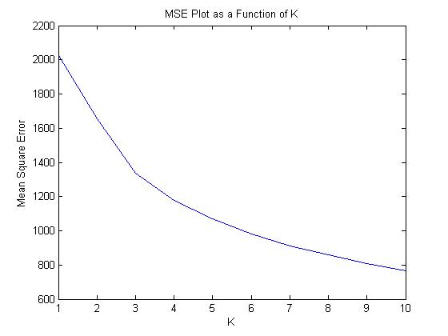

**Part D**

**We are interested in plotting “mean +/- Alpha * V” As there are two possible cases, plus and minus, there will have 6 resultant images. The first set of code address “Mean + alpha*V”**

X = load('data/faces.txt'); % load face dataset

n = size(X, 1); % number of faces

mean_d_3 = mean(X, 1); % mean over examples

Xo = X - repmat(mean_d_3, [n,1]); % subtract mean

[U_d_3,S_d_3,V_d_3] = svds(Xo,3);

W_d_3=U_d_3*S_d_3;

for i=1:3

alpha = 2*median(abs(W_d_3(:,i)));

img = reshape((mean_d_3+ alpha*V_d_3(:,i)'),[24 24]);

figure(i)

imagesc(img); axis square; colormap gray;

i=i+1;

end

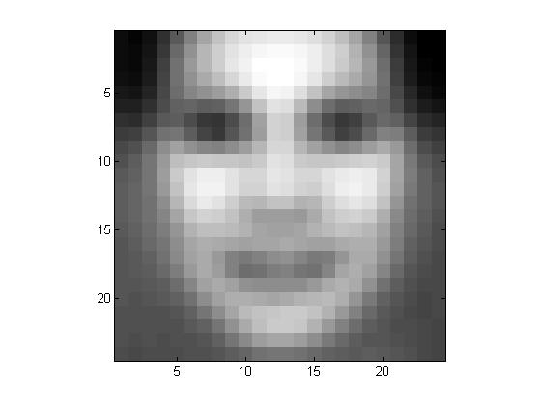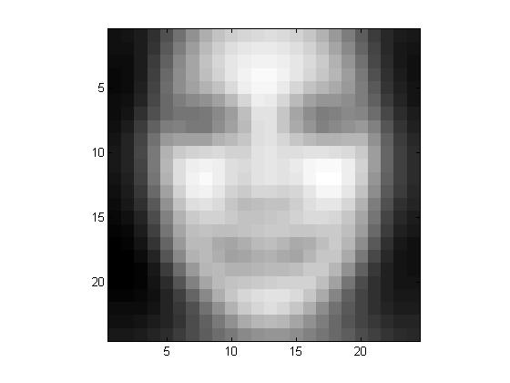 X = load('data/faces.txt'); % load face dataset

n = size(X, 1); % number of faces

mean_d_3 = mean(X, 1); % mean over examples

Xo = X - repmat(mean_d_3, [n,1]); % subtract mean

[U_d_3,S_d_3,V_d_3] = svds(Xo,3);

W_d_3=U_d_3*S_d_3;

for i=1:3

alpha = 2*median(abs(W_d_3(:,i)));

img = reshape((mean_d_3- alpha*V_d_3(:,i)'),[24 24]);

figure(i)

imagesc(img); axis square; colormap gray;

i=i+1;

end

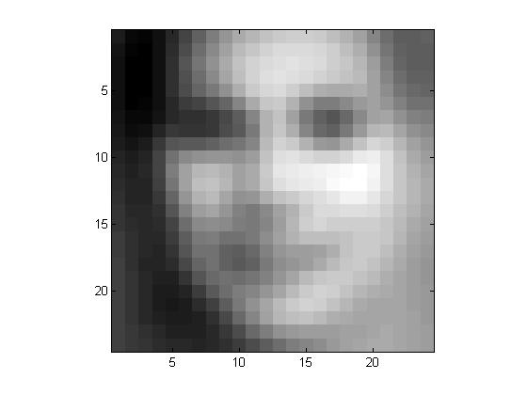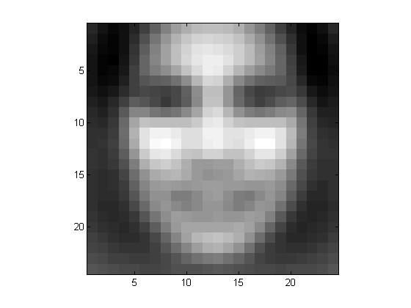

**Part E**

X = load('data/faces.txt'); % load face dataset

n = size(X, 1); % number of faces

mean_e = mean(X, 1); % mean over examples

Xo = X - repmat(mean_e, [n,1]); % subtract mean

[U_d_3,S_d_3,V_d_3] = svds(Xo,3);

W=U_d_3*S_d_3;

idx = randperm(size(Xo, 1)); % randomize indexes

idx = idx(1:20); % take the first 20

figure; hold on; axis ij; colormap(gray);

range = max(W(idx,1:2)) - min(W(idx,1:2)); % find range of coordinates to be plotted

scale = [200 200]./range; % want 24x24 to be visible but not large on new scale

for i=idx, imagesc(W(i,1)*scale(1),W(i,2)*scale(2),reshape(X(i,:),24,24)); end;

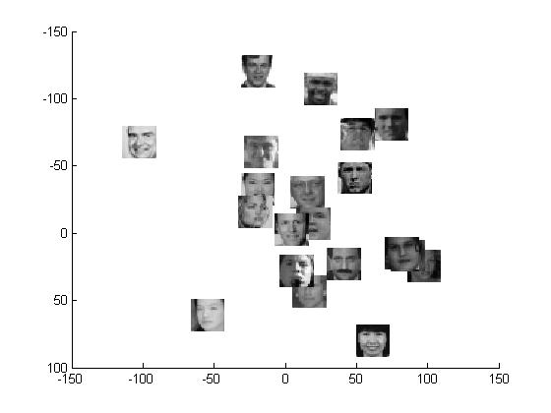

**Part F**

X = load('data/faces.txt'); % load face dataset

n = size(X, 1); % number of faces

mean_e = mean(X, 1); % mean over examples

Xo = X - repmat(mean_e, [n,1]); % subtract mean

idx = randperm(size(Xo, 1)); % randomize indexes

idx = idx(1:2);

k = [5, 10, 50];

f = 0;

for i=1:length(k)

[U, S, V] = svds(Xo, k(i));

W = U * S;

X_hat = W(:, 1:k(i)) * V(:, 1:k(i))';

% Face 1

img = reshape(X_hat(idx(1), :), [24 24]);

f = f + 1;

figure(f);

imagesc(img); axis square; colormap gray;

title(sprintf('Face %g; K = %g', idx(1), k(i)));

% Face 2

img = reshape(X_hat(idx(2), :), [24 24]);

f = f + 1;

figure(f);

imagesc(img); axis square; colormap gray;

title(sprintf('Face %g; K = %g', idx(2), k(i)));

end;

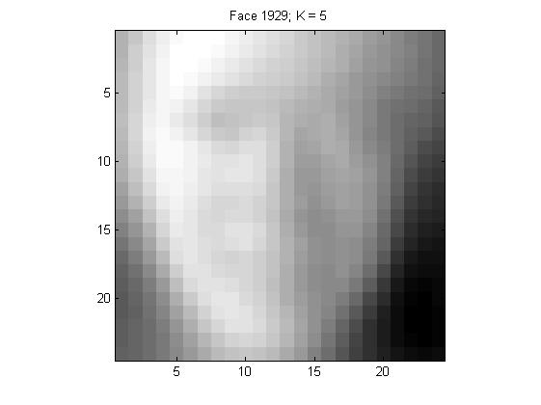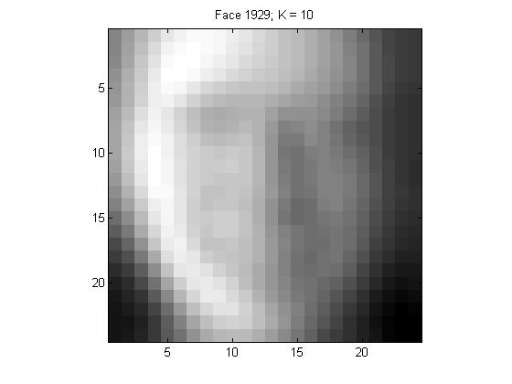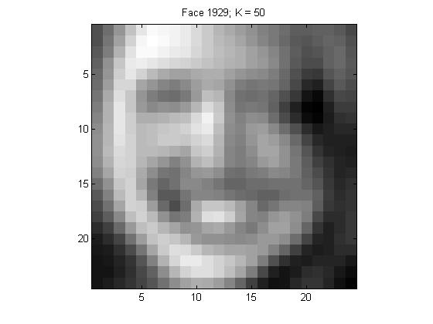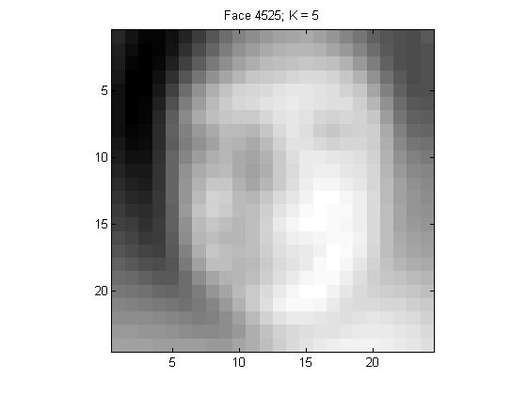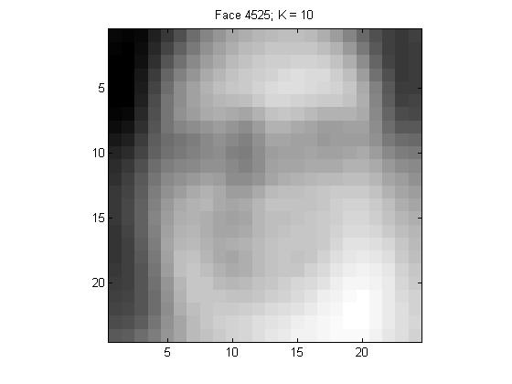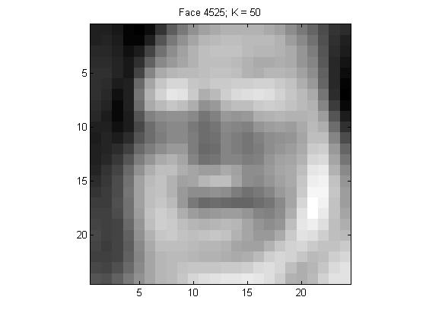

Overall speaking, reconstructed image has better result when number of K increase.